# What is Tailwind CSS?

* [Tailwind CSS](https://www.geeksforgeeks.org/tailwind-css/) can be used to style websites in the fastest and easiest way.
* [Tailwind CSS](https://www.geeksforgeeks.org/tailwind-css/) is basically a **utility-first CSS framework** for rapidly building custom user interfaces.
* It is a highly customizable, low-level [CSS](https://www.geeksforgeeks.org/css-introduction/) framework that gives you all of the building blocks you need to build bespoke(specially made for a particular person, organization, or purpose) designs without any annoying opinionated styles you have to fight to override.
* In Tailwind, you simply bring tiny components together to construct a user interface that is unique.
* Tailwind CSS was created in 2017 by Adam Wathan and Steve Schoger.

“**Utility-first CSS framework packed with classes to build any design.**”

* Unlike Bootstrap, Tailwind CSS doesn’t come with prebuilt classes like dropdown-menu and dropdown-item. (But there is an additional, paid UI kit offered by Tailwind’s creators, since it’s not part of the core offering)
* Instead, it’s up to you to **design and build your own components and design**. They simply provide you with the tools to do it quickly and easily.
* Tailwind CSS comes with some extensions in VS Code (**Tailwind CSS IntelliSense**) that helps you autocomplete suggestions and provide class definitions without needing to leave your editor.
* Tailwind CSS also makes responsive designs easy as they handle all the media queries for you, you just need to use the breakpoint(**xs, sm, md, lg, xl**) you want to target in front of the class you’re using.

Instead of writing CSS yourself and worrying about things like class naming conventions, Tailwind CSS handles it all for you, and you just need to use the classes directly on the elements you wish to style.

* The utility classes like p-4, text-center, and rounded-full. These are all abstractions of traditional CSS properties: padding, text-align, and border-radius.

**Now let’s take a look at a basic example of Tailwind CSS:**

<div class="bg-gray-200 p-4">

<h2 class="font-bold text-lg">Lizard</h2>

</div>

**This shows an example application of different Tailwind CSS utility classes, such as:**

• bg-gray-200 for the background color

•

p

-

4

for padding

•

font

-

bold and text

-

lg for text styling

# Why [Tailwind CSS?](https://www.geeksforgeeks.org/tailwind-css/)

* The faster UI building process.
* If having a unique design is vital to the project or your brand identity, then having the freedom to build completely custom might be the best choice, and that's what Tailwind CSS offers you.
* This means you need to design and build all your components from scratch.
* Tailwind’s utility-first approach with highly customizable classes allows for greater styling flexibility suited to projects that need heavy customization and branding.

As we know there are many CSS frameworks but people always choose the fast and easy framework to learn and use in the project. Tailwind has come with inbuilt a lot of features and styles for users to choose from and is also used to reduce the tendency of writing CSS code and create a beautiful custom UI. It will help you to overcome the complicated task. Tailwind CSS creates small utilities with a defined set of options enabling easy integration of existing classes directly into the HTML code.

**When to Use Tailwind CSS**

* Tailwind CSS is best used to speed up the development process by writing less code.
* It comes with a design system that helps maintain consistency across various design requirements like padding, spacing, and so forth; with this, you do not have to worry about creating your design systems.
* You can also use Tailwind CSS if you are looking to use a framework that is easily configurable because it does not force you to use components (navigation bars, buttons, forms, and so forth) in the same way all the time; you get to choose what your components should look like.
* But you should never use Tailwind if you have not learned and practiced CSS. **Pros and Cons of Tailwind CSS**

**Here are some of the advantages of using Tailwind CSS:**

* Faster development process
* Helps you practice your CSS more as the utilities are similar
* All utilities and components are easily customizable
* The overall file size for production is usually small
* Easy to learn if you already know CSS
* Good documentation for learning

**Some of the disadvantages of using Tailwind CSS include:**

* Your markup might look disorganized for large projects because all the styles are in the HTML files.
* It isn’t easy to learn if you don’t understand CSS well.
* You are forced to build everything from scratch, including your input elements. When you install Tailwind CSS, it removes all default CSS styles.
* Tailwind CSS is not the best option if you are looking to minimize time spent developing your website’s frontend and mainly focusing on the backend logic.

|  |
| --- |
| **Understanding of Various Methods to use tailwind CSS (Installation)** |
| **> Tailwind CLI**  **> Framework Guides**  **> Play CDN** |

# Using Tailwind via CDN

* Use the CDN to try Tailwind right in the browser without any build step.
* Add the CDN script tag to the <head> of your HTML file, and start using Tailwind’s utility classes to style your content.

<script src="https://cdn.tailwindcss.com"></script>

|  |
| --- |
| **Note: There are some limitations when CDN is used. Some of them are:**  • Customize Tailwind’s default theme can’t be used |
| * Directives like @apply, @variants, etc can’t be used * Can’t install third-party plugins |

|  |  |  |
| --- | --- | --- |
| **Find quickly all the class names and CSS properties with below cheat sheets.**  <https://nerdcave.com/tailwind-cheat-sheet> | | |
|  | <https://tailwindcomponents.com/cheatsheet/> |  |

# Spacing

### Padding

Utilities for controlling an element's padding.

**Add padding to a single side**

* Control the padding on one side of an element using the **p{t|r|b|l}-{size}** utilities.
* For example, o **pt-6** would add 1.5rem of padding to the top of an element, o **pr-4** would add 1rem of padding to the right of an element, o **pb-8** would add 2rem of padding to the bottom of an element, o **pl-2** would add 0.5rem of padding to the left of an element.

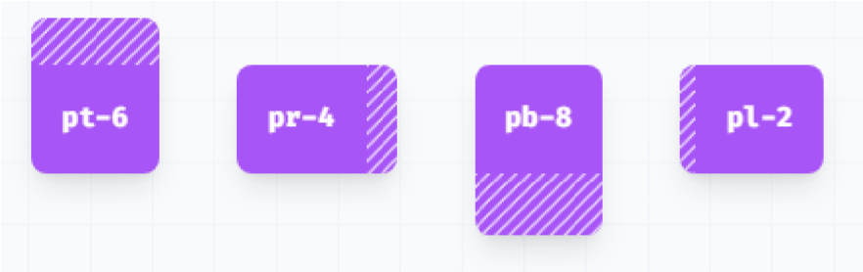

**Add horizontal padding**

Control the horizontal padding of an element using the **px-{size}** utilities.



**Add Vertical padding**

Control the vertical padding of an element using the **py-{size}** utilities.

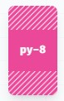

**Add padding to all sides**

Control the padding on all sides of an element using the **p-{size}** utilities.

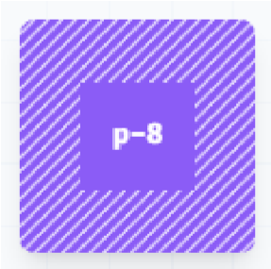

### Margin

Utilities for controlling an element's margin.

**Add margin to a single side**

✓ Control the margin on one side of an element using the **m{t|r|b|l}-{size}** utilities.

* **mt-6** would add 1.5rem of margin to the top of an element,
* **mr-4** would add 1rem of margin to the right of an element, o **mb-8** would add 2rem of margin to the bottom of an element, o **ml-2** would add 0.5rem of margin to the left of an element.

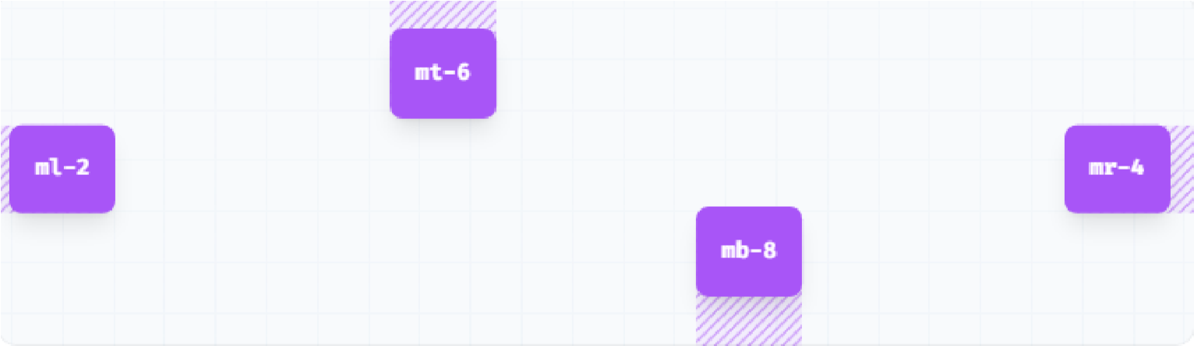

**Add horizontal margin**

Control the horizontal margin of an element using the **mx-{size}** utilities.



**Add vertical margin**

Control the vertical margin of an element using the **my-{size}** utilities.

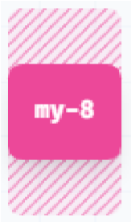

**Add margin to all sides**

Control the margin on all sides of an element using the **m-{size}** utilities.



|  |  |  |  |  |  |  |
| --- | --- | --- | --- | --- | --- | --- |
| **Class** |  | | | | **CSS Property value** | **Pixel Value** |
| .m-0 |  | | | | margin: 0px; |  |
| .m-1 |  | | | | margin: 0.25rem; | 4px |
| .m-2 |  | | | | margin: 0.5rem; | 8px |
| .m-3 |  | | | | margin: 0.75rem; | 12px |
| .m-4 |  | | | | margin: 1rem; | 16px |
| .m-5 |  | | | | margin: 1.25rem; | 20px |
| .m-6 |  | | | | margin: 1.5rem; | 24px |
| .m-7 |  | | | | margin: 1.75rem; | 28px |
| .m-8 |  | | | | margin: 2rem; | 32px |
| .m-9 |  | | | | margin: 2.25rem; | 36px |
| .m-1 | 0 |  | | | margin: 2.5rem; | 40px |
| .m-1 | 1 |  | | | margin: 2.75rem; | 44px |
| .m-12 | |  |  | | margin: 3rem; | 48px |
| .m-14 | |  |  | | margin: 3.5rem; | 56px |
| .m-16 | |  |  | | margin: 4rem; | 64px |
| .m-20 | |  |  | | margin: 5rem; | 80px |
| .m-24 | |  |  | | margin: 6rem; | 96px |
| .m-28 | |  |  | | margin: 7rem; | 112px |
| .m-32 | |  |  | | margin: 8rem; | 128px |
| .m-36 | |  |  | | margin: 9rem; | 144px |
| .m-40 | |  |  | | margin: 10rem; | 160px |
| .m-44 | |  |  | | margin: 11rem; | 176px |
| .m-48 | |  |  | | margin: 12rem; | 192px |
| .m-52 | |  |  | | margin: 13rem; | 208px |
| .m-56 | |  |  | | margin: 14rem; | 224px |
| .m-60 | |  |  | | margin: 15rem; | 240px |
| .m-64 | |  |  | | margin: 16rem; | 256px |
| .m-72 | |  |  | | margin: 18rem; | 288px |
| .m-80 | |  |  | | margin: 20rem; | 320px |
| .m-96 | |  |  | | margin: 24rem; | 384px |
| .m-au | | | to |  | margin: auto; |  |
| .m-px | |  |  | | margin: 1px; |  |
| .m-0.5 | | |  | | margin: 0.125rem; | 2px |
| .m-1.5 | | |  | | margin: 0.375rem; | 6px |
| .m-2.5 | | |  | | margin: 0.625rem; | 10px |
| .m-3.5 | | |  | | margin: 0.875rem; | 14px |

**Use same values for the specific sides like right(mr), left(ml), top(mt), bottom(mb) and also same for the padding.**

# Sizing

In Tailwind, the height and width properties are denoted by the .**h-{number}** and **.w{number}** classes. **Height**

Fixed heights

Use **h-{number}** or h-px to set an element to a fixed height.

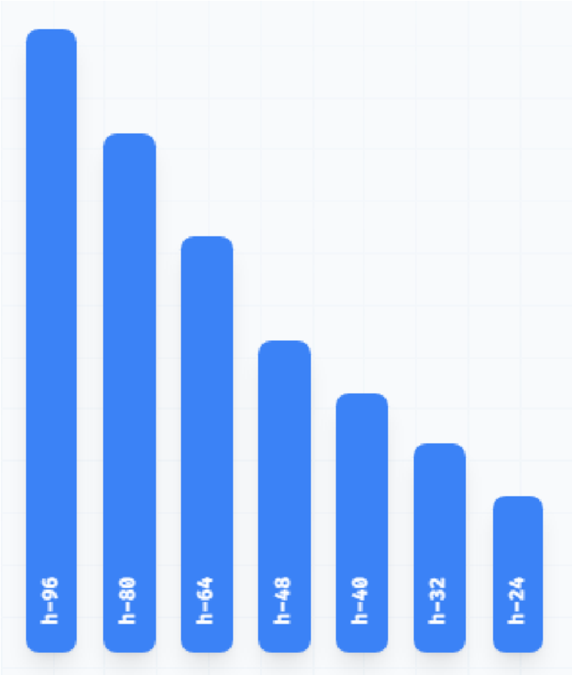

|  |  |
| --- | --- |
| **h-0** | height: 0px; |
| **h-px** | height: 1px; |
| **h-0.5** | height: 0.125rem; /* 2px */ |
| **h-1** | height: 0.25rem; /* 4px */ |
| **h-1.5** | height: 0.375rem; /* 6px */ |
| **h-2** | height: 0.5rem; /* 8px */ |
| **h-2.5** | height: 0.625rem; /* 10px */ |
| **h-3** | height: 0.75rem; /* 12px */ |
| **h-3.5** | height: 0.875rem; /* 14px */ |
| **h-4** | height: 1rem; /* 16px */ |
| **h-5** | height: 1.25rem; /* 20px */ |
| **h-6** | height: 1.5rem; /* 24px */ |
| **h-7** | height: 1.75rem; /* 28px */ |
| **h-8** | height: 2rem; /* 32px */ |
| **h-9** | height: 2.25rem; /* 36px */ |
| **h-10** | height: 2.5rem; /* 40px */ |
| **h-11** | height: 2.75rem; /* 44px */ |
| **h-12** | height: 3rem; /* 48px */ |
| **h-14** | height: 3.5rem; /* 56px */ |
| **h-16** | height: 4rem; /* 64px */ |
| **h-20** | height: 5rem; /* 80px */ |
| **h-24** | height: 6rem; /* 96px */ |
| **h-28** | height: 7rem; /* 112px */ |
| **h-32** | height: 8rem; /* 128px */ |
| **h-36** | height: 9rem; /* 144px */ |
| **h-40** | height: 10rem; /* 160px */ |
| **h-44** | height: 11rem; /* 176px */ |
| **h-48** | height: 12rem; /* 192px */ |
| **h-52** | height: 13rem; /* 208px */ |
| **h-56** | height: 14rem; /* 224px */ |
| **h-60** | height: 15rem; /* 240px */ |
| **h-64** | height: 16rem; /* 256px */ |
| **h-72** | height: 18rem; /* 288px */ |
| **h-80** | height: 20rem; /* 320px */ |
| **h-96** | height: 24rem; /* 384px */ |
| **h-auto** | height: auto; |
| **h-1/2** | height: 50%; |
| **h-1/3** | height: 33.333333%; |
| **h-2/3** | height: 66.666667%; |
| **h-1/4** | height: 25%; |
| **h-2/4** | height: 50%; |
| **h-3/4** | height: 75%; |
| **h-1/5** | height: 20%; |
| **h-2/5** | height: 40%; |
| **h-3/5** | height: 60%; |
| **h-4/5** | height: 80%; |
| **h-1/6** | height: 16.666667%; |
| **h-2/6** | height: 33.333333%; |
| **h-3/6** | height: 50%; |
| **h-4/6** | height: 66.666667%; |
| **h-5/6** | height: 83.333333%; |
| **h-full** | height: 100%; |
| **h-screen** | height: 100vh; |

**Full height**

Use **h-full** to set an element’s height to 100% of its parent, as long as the parent has a defined height.

**Viewport height**

Use **h-screen** to make an element span the entire height of the viewport.

**Width**

Utilities for setting the width of an element. **Fixed widths**

Use **w-{number}** or **w-px** to set an element to a fixed width.

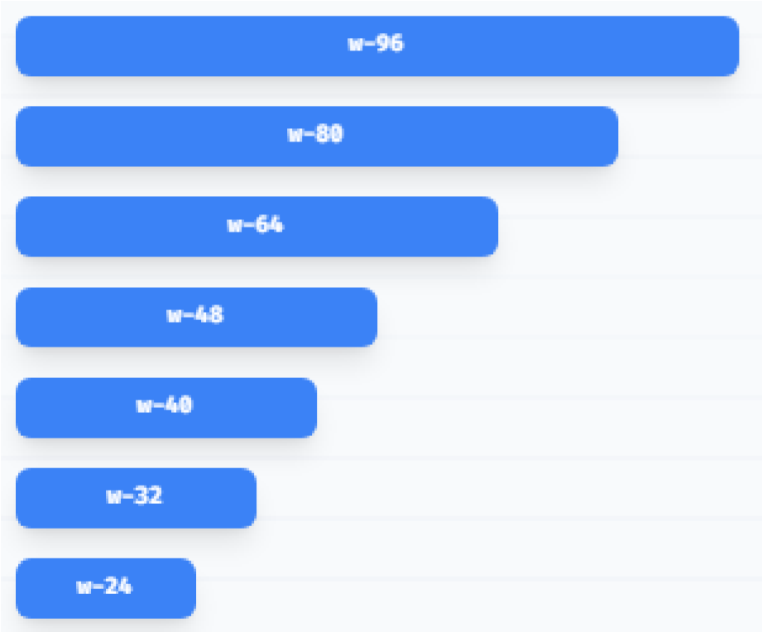

|  |  |
| --- | --- |
| **w-0** | width: 0px; |
| **w-px** | width: 1px; |
| **w-0.5** | width: 0.125rem; /* 2px */ |
| **w-1** | width: 0.25rem; /* 4px */ |
| **w-1.5** | width: 0.375rem; /* 6px */ |
| **w-2** | width: 0.5rem; /* 8px */ |
| **w-2.5** | width: 0.625rem; /* 10px */ |
| **w-3** | width: 0.75rem; /* 12px */ |
| **w-3.5** | width: 0.875rem; /* 14px */ |
| **w-4** | width: 1rem; /* 16px */ |
| **w-5** | width: 1.25rem; /* 20px */ |
| **w-6** | width: 1.5rem; /* 24px */ |
| **w-7** | width: 1.75rem; /* 28px */ |
| **w-8** | width: 2rem; /* 32px */ |
| **w-9** | width: 2.25rem; /* 36px */ |
| **w-10** | width: 2.5rem; /* 40px */ |
| **w-11** | width: 2.75rem; /* 44px */ |
| **w-12** | width: 3rem; /* 48px */ |
| **w-14** | width: 3.5rem; /* 56px */ |
| **w-16** | width: 4rem; /* 64px */ |
| **w-20** | width: 5rem; /* 80px */ |
| **w-24** | width: 6rem; /* 96px */ |
| **w-28** | width: 7rem; /* 112px */ |
| **w-32** | width: 8rem; /* 128px */ |
| **w-36** | width: 9rem; /* 144px */ |
| **w-40** | width: 10rem; /* 160px */ |
| **w-44** | width: 11rem; /* 176px */ |
| **w-48** | width: 12rem; /* 192px */ |
| **w-52** | width: 13rem; /* 208px */ |
| **w-56** | width: 14rem; /* 224px */ |
| **w-60** | width: 15rem; /* 240px */ |
| **w-64** | width: 16rem; /* 256px */ |
| **w-72** | width: 18rem; /* 288px */ |
| **w-80** | width: 20rem; /* 320px */ |
| **w-96** | width: 24rem; /* 384px */ |
| **w-auto** | width: auto; |
| **w-1/2** | width: 50%; |
| **w-1/3** | width: 33.333333%; |
| **w-2/3** | width: 66.666667%; |
| **w-1/4** | width: 25%; |
| **w-2/4** | width: 50%; |
| **w-3/4** | width: 75%; |
| **w-1/5** | width: 20%; |
| **w-2/5** | width: 40%; |
| **w-3/5** | width: 60%; |
| **w-4/5** | width: 80%; |
| **w-1/6** | width: 16.666667%; |
| **w-2/6** | width: 33.333333%; |
| **w-3/6** | width: 50%; |
| **w-4/6** | width: 66.666667%; |
| **w-5/6** | width: 83.333333%; |
| **w-1/12** | width: 8.333333%; |
| **w-2/12** | width: 16.666667%; |
| **w-3/12** | width: 25%; |
| **w-4/12** | width: 33.333333%; |
| **w-5/12** | width: 41.666667%; |
| **w-6/12** | width: 50%; |
| **w-7/12** | width: 58.333333%; |
| **w-8/12** | width: 66.666667%; |
| **w-9/12** | width: 75%; |
| **w-10/12** | width: 83.333333%; |
| **w-11/12** | width: 91.666667%; |
| **w-full** | width: 100%; |
| **w-screen** | width: 100vw; |

**Full Width**

Use **w-full** to set an element’s width to 100%.

**Viewport width**

Use **w-screen** to make an element span the entire width of the viewport.

**Setting the minimum width**

Set the minimum width of an element using

**min**

**-**

**w**

**-**

**\***

utilities.

**Setting the maximum width**

Set the maximum width of an element using the

**max**

**-**

**w**

**-**

**\***

utilities.

Setting the minimum height

Set the minimum height of an element using **min-h-\*** utilities.

Setting the maximum height

Set the maximum height of an element using **max-h-\*** utilities.

**\*** values can be 0, px, 0.5, 1, 1.5, 2, 2.5, 3, 3.5, 4, 5, 6, 7, 8, 9, 10, 11, 12, 14, 16, 20, 24, 28, 32, 36, 40, 44, 48, 52, 56, 60, 64, 72, 80, 96 etc

**Typography**

|  |
| --- |
| **Text color** |
| text-inherit | | text-current | texttransparent | text-black | text-white | text-slate-50 |
| text-slate100 | | text-slate200 | text-slate-300 | text-slate400 | text-slate500 | text-slate600 |
| text-slate700 | | text-slate800 | text-slate-900 | text-slate950 | text-gray-50 | text-gray100 |
| text-gray200 | | text-gray300 | text-gray-400 | text-gray500 | text-gray600 | text-gray700 |
| text-gray800 | | text-gray900 | text-gray-950 | text-zinc-50 | text-zinc-100 | text-zinc-200 |
| text-zinc-300 | | text-zinc-400 | text-zinc-500 | text-zinc-600 | text-zinc-700 | text-zinc-800 |
| text-zinc-900 | | text-zinc-950 | text-neutral50 | text-neutral100 | text-neutral200 | text-neutral300 |
| text-neutral400 | | text-neutral500 | text-neutral600 | text-neutral700 | text-neutral800 | text-neutral900 |
| text-neutral950 | | text-stone50 | text-stone100 | text-stone200 | text-stone300 | text-stone400 |
| text-stone500 | | text-stone600 | text-stone700 | text-stone800 | text-stone900 | text-stone950 |
| text-red-50 | | text-red-100 | text-red-200 | text-red-300 | text-red-400 | text-red-500 |
| text-red-600 | | text-red-700 | text-red-800 | text-red-900 | text-red-950 | text-orange50 |
| text-orange100 | | text-orange200 | text-orange300 | text-orange400 | text-orange500 | text-orange600 |
| text-orange700 | | text-orange800 | text-orange900 | text-orange950 | text-amber50 | text-amber100 |
| text-amber200 | | text-amber300 | text-amber400 | text-amber500 | text-amber600 | text-amber700 |
| text-amber800 | | text-amber900 | text-amber950 | text-yellow50 | text-yellow100 | text-yellow200 |
| text-yellow300 | | text-yellow400 | text-yellow500 | text-yellow600 | text-yellow700 | text-yellow800 |
| text-yellow900 | | text-yellow950 | text-lime-50 | text-lime100 | text-lime200 | text-lime300 |
| text-lime400 | | text-lime500 | text-lime-600 | text-lime700 | text-lime800 | text-lime900 |
| text-lime950 | | text-green50 | text-green100 | text-green200 | text-green300 | text-green400 |
| text-green500 | | text-green600 | text-green700 | text-green800 | text-green900 | text-green950 |
| textemerald-50 | | textemerald-100 | text-emerald200 | textemerald-300 | textemerald-400 | textemerald-500 |
| textemerald-600 | | textemerald-700 | text-emerald800 | textemerald-900 | textemerald-950 | text-teal-50 |
| text-teal-100 | | text-teal-200 | text-teal-300 | text-teal-400 | text-teal-500 | text-teal-600 |
| text-teal-700 | | text-teal-800 | text-teal-900 | text-teal-950 | text-cyan-50 | text-cyan100 |
| text-cyan200 | | text-cyan300 | text-cyan-400 | text-cyan500 | text-cyan600 | text-cyan700 |
| text-cyan800 | | text-cyan900 | text-cyan-950 | text-sky-50 | text-sky-100 | text-sky-200 |
| text-sky-300 | | text-sky-400 | text-sky-500 | text-sky-600 | text-sky-700 | text-sky-800 |
| text-sky-900 | | text-sky-950 | text-blue-50 | text-blue100 | text-blue200 | text-blue300 |
| text-blue400 | | text-blue500 | text-blue-600 | text-blue700 | text-blue800 | text-blue900 |
| text-blue950 | | text-indigo50 | text-indigo100 | text-indigo200 | text-indigo300 | text-indigo400 |
| text-indigo500 | | text-indigo600 | text-indigo700 | text-indigo800 | text-indigo900 | text-indigo950 |
| text-violet50 | | text-violet100 | text-violet200 | text-violet300 | text-violet400 | text-violet500 |
| text-violet600 | | text-violet700 | text-violet800 | text-violet900 | text-violet950 | text-purple50 |
| text-purple100 | | text-purple200 | text-purple300 | text-purple400 | text-purple500 | text-purple600 |
| text-purple700 | | text-purple800 | text-purple900 | text-purple950 | text-fuchsia50 | text-fuchsia100 |
| text-fuchsia200 | | text-fuchsia300 | text-fuchsia400 | text-fuchsia500 | text-fuchsia600 | text-fuchsia700 |
| text-fuchsia800 | | text-fuchsia900 | text-fuchsia950 | text-pink-50 | text-pink100 | text-pink200 |
| text-pink300 | | text-pink400 | text-pink-500 | text-pink600 | text-pink700 | text-pink800 |
| text-pink900 | | text-pink950 | text-rose-50 | text-rose100 | text-rose200 | text-rose300 |
| text-rose400 | | text-rose500 | text-rose-600 | text-rose700 | text-rose800 | text-rose900 |
| text-rose950 | |  |  |  |  |  |

**Note:** **The color’s values can be changeable according to your need from 50-950.**

Sample example of colors

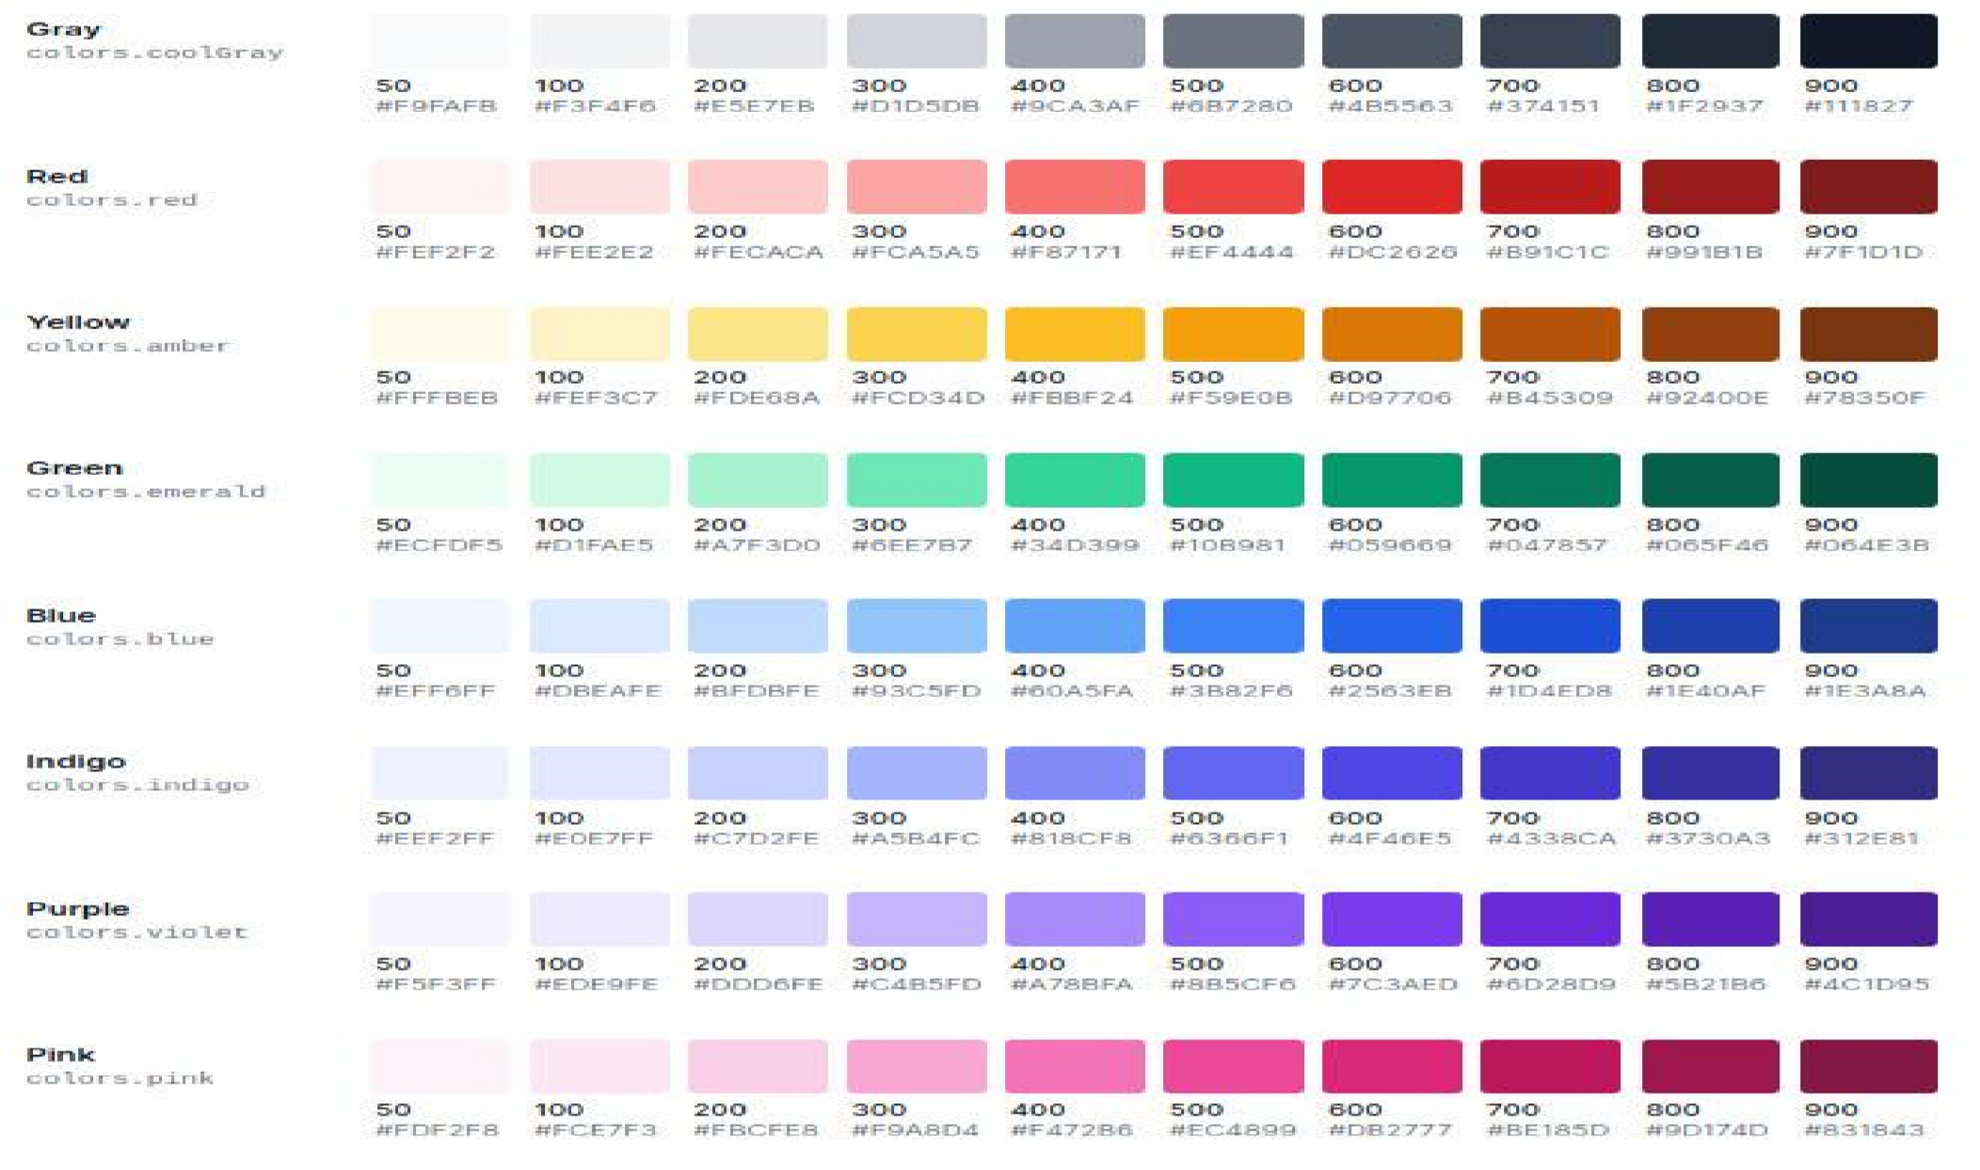

|  |
| --- |
| **Text opacity** |

Control the opacity of an element’s placeholder color using the **text-opacity-{amount}** utilities.

**Note:** The number of the opacity can be changeable from 0 to 100 with the span of 5.

Example:

<p class="text-red-800 p-2 text-3xl">Tailwind Tutorial</p>

<p class="text-red-800 **text-opacity-75** p-2 text-3xl">Tailwind Tutorial</p>

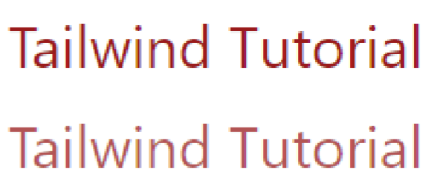

|  |
| --- |
| **Font family** |

Font family classes:

* **font-sans**
* **font-serif**
* **font-mono**

|  |  |  |  |  |  |
| --- | --- | --- | --- | --- | --- |
|  | fontsans |  |  | font-family: system-ui, -apple-system,  BlinkMacSystemFont, "Segoe UI", Roboto, "Helvetica  Neue", Arial, "Noto Sans", sans-serif, "Apple Color Emoji",  "Segoe UI Emoji", "Segoe UI Symbol", "Noto Color Emoji"; |  |
|  |
|  | fontserif |  |  | font-family: Georgia, Cambria, "Times New Roman", Times, serif; |  |
|  | font-  mono |  |  | font-family: Menlo, Monaco, Consolas, "Liberation Mono", "Courier New", monospace; |  |

**Example:**

<p class="text-red-800 p-2 text-3xl **font-sans**">Font Sans</p>

<p class="text-red-800 p-2 text-3xl **font-serif**">Font Serif</p>

<p class="text-red-800 p-2 text-3xl **font-mono**">Font Mono</p>

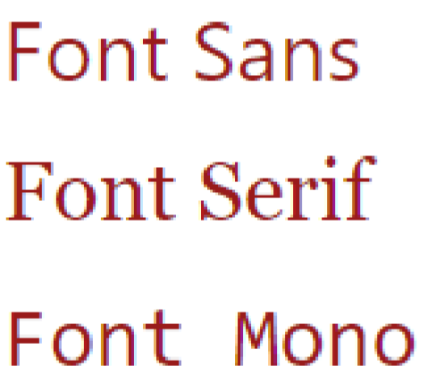

|  |
| --- |
| **Font size** |

**Font size classes:**

**text-xs** This class defines the text size as extra small.

**text-sm** This class defines the text size as small. **text-base** This class defines the text size as base size. **text-lg** This class defines the text size as large. **text-xl** This class defines the text size as extra-large. **text-2xl** This class defines the text size as 2 times extra-large. **text-3xl** This class defines the text size as 3 times extra-large. **text-4xl** This class defines the text size as 4 times extra-large. **text-5xl** This class defines the text size as 5 times extra-large. **text-6xl** This class defines the text size as 6 times extra-large. **text-7xl** This class defines the text size as 7 times extra-large. **text-8xl** This class defines the text size as 8 times extra-large. **text-9xl** This class defines the text size as 9 times extra-large.

**Note:** Change the size in the component with the required size mentioned above.

Example:

<p class="text-red-800 p-2 **text-xs**">XS</p>

<p class="text-red-800 p-2 **text-sm**">SM</p>

<p class="text-red-800 p-2 **text-base**">BASE</p>

|  |
| --- |
| **Font style** |

**Font Style classes:** ✓ italic

<

p class="text

-

red

-

800

p

-

2

**text**

**-**

**lg**

">LG</p>

<

p class="text

-

red

-

800

p

-

2

**text**

**-**

**xl**

">XL</p>

<

p class="text

-

red

-

800

p

-

2

**text**

**-**

**5**

**xl**

">5XL</p>

<

p class="text

-

red

-

800

p

-

2

**text**

**-**

**9**

**xl**

">9XL</p>

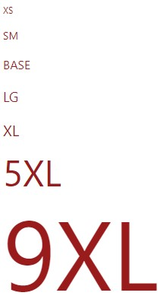

✓ non-italic

|  |  |
| --- | --- |
| **italic** | This class is used to set the font style as *italic*. |
| **non-italic** | This is basically the default font, which is used to reset italic text at different breakpoints. |

Example:

<p class="text-red-800 p-2 text-5xl **italic**">Italic</p>

<p class="text-red-800 p-2 text-5xl **non-italic**">Non Italic</p>



|  |
| --- |
| **Font weight** |

**Font weight classes:**

|  |  |
| --- | --- |
| **font-thin** | This class sets the *font-weight* to 100. |
| **font-extralight** | This class sets the *font-weight* to 200. |
| **font-light** | This class sets the *font-weight* to 300. |
| **font-normal** | This class sets the *font-weight* to 400. |
| **font-medium** | This class sets the *font-weight* to 500. |
| **font-semibold** | This class sets the *font-weight* to 600. |
| **font-bold** | This class sets the *font-weight* to 700. |
| **font-extrabold** | This class sets the *font-weight* to 800. |
| **font-black** | This class sets the *font-weight* to 900. |

|  |
| --- |
| **List style type** |

Utilities for controlling the bullet/number style of a list.

**List Style Type classes:**

|  |  |
| --- | --- |
| **list-none** | No marker is shown in this mode. |
| **list-disc** | This is the default value. The marker is a filled circle. |
| **list-decimal** | A marker is a decimal number, beginning with 1. |

**Syntax:**

<element class="List Style Type">...</element>

|  |
| --- |
| **Text align** |

This class is used to specify the horizontal alignment of text in an element. **Text Alignment classes:**

|  |
| --- |
| **text-left** |
| **text-center** |
| **text-right** |
| **text-justify** |

|  |
| --- |
| **Text decoration** |

This class is used to “decorate” the content of the text. It is essentially decorating the text with different kinds of lines. **Text Decoration classes:**

|  |
| --- |
| **underline** |
| **line-through** |
| **no-underline** |

|  |
| --- |
| **Text transform** |

This class is used to control the capitalization of the text. **Text Transform classes:**

|  |
| --- |
| **uppercase** |
| **lowercase** |
| **capitalize** |
| **normal-case** |

Example:

|  |
| --- |
| <div class="m-24">  <ul class="**list-disc**">  <li class="**line-through**">test</li>  <li class="**underline**">test 1</li>  <li class="**capitalize** **font-extralight**">test 2</li> </ul>  <br>  <ol class="**list-decimal**">  <li class="**uppercase** **font-bold**">test</li>  <li>test 1</li>  <li>test 2</li>  </ol>  <br>  <ul class="**list-none**">  <li>test</li>  <li class="**font-extrabold**">test 1</li>  <li>test 2</li>  </ul>  </div> |

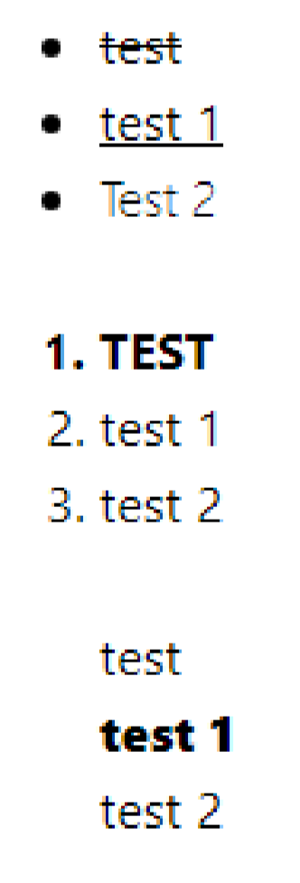

**Arbitrary values**

If you need to use a one-off value that doesn’t make sense to include in your theme, use square brackets to generate a property on the fly using any arbitrary value.

<p class="**text-[#50d71e]**">

<!-- ... -->

</p>

**Background**

### Background color

* Control the background color of an element using the **bg-{color}** utilities.
* This class is used to specify the background color of an element. The background covers the total size of the element with padding and border but excluding margin. It makes the text so easy to read for the user.

**Background Color classes:**

|  |  |  |  |  |  |
| --- | --- | --- | --- | --- | --- |
| bg-inherit | bg-current | bgtransparent | bg-black | bg-white | bg-slate-50 |
| bg-slate-100 | bg-slate-200 | bg-slate-300 | bg-slate-400 | bg-slate-500 | bg-slate-600 |
| bg-slate-700 | bg-slate-800 | bg-slate-900 | bg-slate-950 | bg-gray-50 | bg-gray-100 |
| bg-gray-200 | bg-gray-300 | bg-gray-400 | bg-gray-500 | bg-gray-600 | bg-gray-700 |
| bg-gray-800 | bg-gray-900 | bg-gray-950 | bg-zinc-50 | bg-zinc-100 | bg-zinc-200 |
| bg-zinc-300 | bg-zinc-400 | bg-zinc-500 | bg-zinc-600 | bg-zinc-700 | bg-zinc-800 |
| bg-zinc-900 | bg-zinc-950 | bg-neutral-50 | bg-neutral100 | bg-neutral200 | bg-neutral300 |
| bg-neutral400 | bg-neutral500 | bg-neutral600 | bg-neutral700 | bg-neutral800 | bg-neutral900 |
| bg-neutral950 | bg-stone-50 | bg-stone-100 | bg-stone200 | bg-stone300 | bg-stone400 |
| bg-stone500 | bg-stone600 | bg-stone-700 | bg-stone800 | bg-stone900 | bg-stone950 |
| bg-red-50 | bg-red-100 | bg-red-200 | bg-red-300 | bg-red-400 | bg-red-500 |
| bg-red-600 | bg-red-700 | bg-red-800 | bg-red-900 | bg-red-950 | bg-orange50 |
| bg-orange100 | bg-orange200 | bg-orange300 | bg-orange400 | bg-orange500 | bg-orange600 |
| bg-orange700 | bg-orange800 | bg-orange900 | bg-orange950 | bg-amber-50 | bg-amber100 |
| bg-amber200 | bg-amber300 | bg-amber-400 | bg-amber500 | bg-amber600 | bg-amber700 |
| bg-amber800 | bg-amber900 | bg-amber-950 | bg-yellow-50 | bg-yellow100 | bg-yellow200 |
| bg-yellow300 | bg-yellow400 | bg-yellow-500 | bg-yellow600 | bg-yellow700 | bg-yellow800 |
| bg-yellow900 | bg-yellow950 | bg-lime-50 | bg-lime-100 | bg-lime-200 | bg-lime-300 |
| bg-lime-400 | bg-lime-500 | bg-lime-600 | bg-lime-700 | bg-lime-800 | bg-lime-900 |
| bg-lime-950 | bg-green-50 | bg-green-100 | bg-green200 | bg-green300 | bg-green400 |
| bg-green500 | bg-green600 | bg-green-700 | bg-green800 | bg-green900 | bg-green950 |
| bg-emerald50 | bg-emerald100 | bg-emerald200 | bg-emerald300 | bg-emerald400 | bg-emerald500 |
| bg-emerald600 | bg-emerald700 | bg-emerald800 | bg-emerald900 | bg-emerald950 | bg-teal-50 |
| bg-teal-100 | bg-teal-200 | bg-teal-300 | bg-teal-400 | bg-teal-500 | bg-teal-600 |
| bg-teal-700 | bg-teal-800 | bg-teal-900 | bg-teal-950 | bg-cyan-50 | bg-cyan-100 |
| bg-cyan-200 | bg-cyan-300 | bg-cyan-400 | bg-cyan-500 | bg-cyan-600 | bg-cyan-700 |
| bg-cyan-800 | bg-cyan-900 | bg-cyan-950 | bg-sky-50 | bg-sky-100 | bg-sky-200 |
| bg-sky-300 | bg-sky-400 | bg-sky-500 | bg-sky-600 | bg-sky-700 | bg-sky-800 |
| bg-sky-900 | bg-sky-950 | bg-blue-50 | bg-blue-100 | bg-blue-200 | bg-blue-300 |
| bg-blue-400 | bg-blue-500 | bg-blue-600 | bg-blue-700 | bg-blue-800 | bg-blue-900 |
| bg-blue-950 | bg-indigo-50 | bg-indigo-100 | bg-indigo200 | bg-indigo300 | bg-indigo400 |
| bg-indigo500 | bg-indigo600 | bg-indigo-700 | bg-indigo800 | bg-indigo900 | bg-indigo950 |
| bg-violet-50 | bg-violet100 | bg-violet-200 | bg-violet300 | bg-violet400 | bg-violet500 |
| bg-violet600 | bg-violet700 | bg-violet-800 | bg-violet900 | bg-violet950 | bg-purple-50 |
| bg-purple100 | bg-purple200 | bg-purple-300 | bg-purple400 | bg-purple500 | bg-purple600 |
| bg-purple700 | bg-purple800 | bg-purple-900 | bg-purple950 | bg-fuchsia50 | bg-fuchsia100 |
| bg-fuchsia200 | bg-fuchsia300 | bg-fuchsia400 | bg-fuchsia500 | bg-fuchsia600 | bg-fuchsia700 |
| bg-fuchsia800 | bg-fuchsia900 | bg-fuchsia950 | bg-pink-50 | bg-pink-100 | bg-pink-200 |
| bg-pink-300 | bg-pink-400 | bg-pink-500 | bg-pink-600 | bg-pink-700 | bg-pink-800 |
| bg-pink-900 | bg-pink-950 | bg-rose-50 | bg-rose-100 | bg-rose-200 | bg-rose-300 |
| bg-rose-400 | bg-rose-500 | bg-rose-600 | bg-rose-700 | bg-rose-800 | bg-rose-900 |
| bg-rose-950 |  |  |  |  |  |

**Note:** The color’s values can be changeable according to your need from 50-950.

**Example:**

<

body class="text

-

center mx

-

4

">

<

h1 class="text

-

green

-

600

text

-

5

xl font

-

bold">

Tailwind CSS Background Color Class

/h1>

<

<div class="mx-14 **bg-green-200** text-justify p-4">

<p class="**bg-transparent** p-2">Transparent</p>

<p class="**bg-current** text-yellow-600 p-2">Current</p>

<p class="**bg-white** p-2"> White </p>

<p class="**bg-black** text-white p-2">Black</p>

<p class="**bg-gray-700** p-2"> Gray</p>

<p class="**bg-red-700** p-2"> Red</p>

<p class="**bg-indigo-700** p-2">Indigo</p>

<p class="**bg-blue-700** p-2"> Blue</p>

<p class="**bg-green-700** p-2">Green</p>

<p class="**bg-yellow-700** p-2"> Yellow</p>

<p class="**bg-pink-700** p-2">Pink</p>

<p class="**bg-purple-700** p-2"> Purple</p>

</div>

</body>

#### Example:

Design a **layout** using **Tailwind CSS** that consists of a **container** with a height of 350px, a yellow background, and padding. Inside this container, create two text blocks:

1. The **first block** should occupy **half the height** of the container, have a **blue background**, display "Hello" in **90px red text** and **center-aligned**.
2. The **second block** should occupy **one-fourth the height** of the container, have a **rosecolored background**, display "Hello" in **90px green text** and **right-aligned**

<div class="h-[350px] bg-yellow-300 p-5 m-3">

<div class="h-1/2 bg-blue-300 text-[90px] text-red-500 text-center m-3">Hello</div>

<div class="h-1/6 bg-rose-300 text-[90px] text-green-500 text-right m-3">Hello</div> </div>

**Background Attachment**

**Utilities for controlling how a background image behaves when scrolling. bg-fixed (background-attachment: fixed; )**

The background is fixed relative to the viewport. Even if an element has a scrolling mechanism, the background doesn't move with the element.

**bg-local (background-attachment: local; )**

The background is fixed relative to the element's contents. If the element has a scrolling mechanism, the background scrolls with the element's contents, and the background painting area and background positioning area are relative to the scrollable area of the element rather than to the border framing them.

**bg-scroll (background-attachment: scroll; )**

The background is fixed relative to the element itself and does not scroll with its contents.

Reference Link: https://tailwindcss.com/docs/background-attachment

**Background Position**

**Utilities for controlling the position of an element's background image.**

Use the **bg-{side}** utilities to control the position of an element’s background image.

|  |  |
| --- | --- |
| **bg-bottom** | background-position: bottom; |
| **bg-center** | background-position: center; |
| **bg-left** | background-position: left; |
| **bg-left-bottom** | background-position: left bottom; |
| **bg-left-top** | background-position: left top; |
| **bg-right** | background-position: right; |
| **bg-right-bottom** | background-position: right bottom; |
| **bg-right-top** | background-position: right top; |
| **bg-top** | background-position: top; |

**Background Repeat**

Utilities for controlling the repetition of an element's background image.

|  |  |
| --- | --- |
| **bg-repeat** | background-repeat: repeat; |
| **bg-no-repeat** | background-repeat: no-repeat; |
| **bg-repeat-x** | background-repeat: repeat-x; |
| **bg-repeat-y** | background-repeat: repeat-y; |

* **Repeat**

Use **bg-repeat** to repeat the background image both vertically and horizontally.

<div class="**bg-repeat**" style="background-image: url(...)"></div>

* **No Repeat**

Use **bg-no-repeat** when you don’t want to repeat the background image.

<div class="**bg-no-repeat**" style="background-image: url(...)"> </div>

* **Repeat Horizontally**

Use **bg-repeat-x** to repeat the background image only horizontally.

<div class="**bg-repeat-x**" style="background-image: url(...)"></div>

* **Repeat Vertically**

Use **bg-repeat-y** to repeat the background image only vertically.

<div class="**bg-repeat-y**" style="background-image: url(...)"></div>

**Background Size**

Utilities for controlling the background size of an element's background image.

|  |  |
| --- | --- |
| **bg-auto** | background-size: auto; |
| **bg-cover** | background-size: cover; |
| **bg-contain** | background-size: contain; |

* **Auto**

Use **bg-auto** to display the background image at its default size.

<div class="**bg-auto** bg-no-repeat" style="background-image: url(...)"></div>

* **Cover**

Use **bg-cover** to scale the background image until it fills the background layer.

<div class="**bg-cover**" style="background-image: url(...)"></div>

* **Contain**

Use **bg-contain** to scale the background image to the outer edges without cropping or stretching.

<div class="**bg-contain**" style="background-image: url(...)"></div>

**Examples**

**<div class="m-4 h-96 w-1/2 bg-[url('2.png')]"></div>**

**<div class="m-4 h-96 w-1/2 bg-[url('2.png')] bg-no-repeat bg-cover bg-center"></div>**

|  |
| --- |
| **For understanding purpose Via the style attribute:**  If you prefer to skip the config then you can just add it using the style attribute, like this:    <div **style="background-image: url('../public/images/hero.jpg');"**></div>    **Via using an arbitrary value:**  If you prefer not to use inline styles and have a single-use image then this is the best approach.    <div class="**bg-[url('../public/images/hero.jpg')]**"></div> |

Ensures that the content inside the div is scrollable when it overflows the defined height. This creates a vertical or horizontal scrollbar when necessary.

**Background Image**

Utilities for controlling an element's background image.

To give an element a linear gradient background, use one of the bg-gradient-{direction} utilities, in combination with the gradient color stop utilities.

## Classes

|  |  |
| --- | --- |
| **bg-none** | This class is used **not to set any *linear-gradient***. |
| **bg-gradient-to-t** | This class is used to set the ***linear-gradient* to the top**. |
| **bg-gradient-to-tr** | This class is used to set the ***linear-gradient* to the top right**. |
| **bg-gradient-to-r** | This class is used to set the ***linear-gradient* to right**. |
| **bg-gradient-to-br** | This class is used to set the ***linear-gradient* to the bottom right**. |
| **bg-gradient-to-b** | This class is used to set the ***linear-gradient* to the bottom**. |
| **bg-gradient-to-bl** | This class is used to set the ***linear-gradient* to the bottom left**. |
| **bg-gradient-to-l** | This class is used to set the ***linear-gradient* to left**. |
| **bg-gradient-to-tl** | This class is used to set the***linear-gradient* to the top left**. |

###### Starting color

Set the starting color of a gradient using the **from-{color}** utilities.

<div class="**bg-gradient-to-r** **from-indigo-500**"></div>

###### Ending color

Set the ending color of a gradient using the **to-{color}** utilities.

<div class="**bg-gradient-to-r** **from-cyan-500 to-blue-500**"></div>

Gradients to do not fade in from transparent by default. To fade in from transparent, reverse the gradient direction and use a from-{color} utility.

###### Middle color

Add a middle color to a gradient using the **via-{color}** utilities.

<div class="**bg-gradient-to-r** **from-indigo-500 via-purple-500 to-pink-500**"></div>

Gradients with a from-{color} and via-{color} will fade out to transparent by default if no to{color} is present.

###### Specifying stop positions

For more control over the gradient color stop positions, combine the **from-{position}, via{position} and to-{position}** utilities with the gradient color utilities.

Example:

<div class="m-4 h-24 w-1/2 **bg-gradient-to-r** **from-yellow-400** **via-pink-500 to-blue500**"></div>

<div class="m-4 h-24 w-1/2 **bg-gradient-to-t** **from-indigo-600**"></div>

<div class="m-4 h-24 w-1/2 **bg-gradient-to-tr** **from-pink-500 to-yellow-500**"></div> **Output**

**Add gradient to text**

<h1 class=" text-9xl bg-gradient-to-r from-blue-600 via-green-500 to-indigo-400">Hello World</h1>

This will not add gradient to text. Follow below steps to add gradient to the text.

**Step 1: Add the inline-block class to our element.**

<h1 class=" text-9xl bg-gradient-to-r from-blue-600 via-green-500 to-indigo-400 **inlineblock**">hello world</h1>

Now, the gradient takes up only the width of the text, instead of the width of the parent element.

**Step 2: Make your text transparent**

Make your text transparent using the text-transparent class.

<h1 class=" text-9xl bg-gradient-to-r from-blue-600 via-green-500 to-indigo-400 **inline-block** **text-transparent**">hello world</h1>

The text will disappear.

**Step 3: Clip the text to the background**

This is the most important thing for making gradient text, it uses the background-clip CSS property, which has multiple values and one of them is text, to use that specific property and value in Tailwind CSS we just need to add the **bg-clip-text** class.

<h1 class="text-9xl bg-gradient-to-r from-blue-600 via-green-500 to-indigo-400 **inline-block** **text-transparent** **bg-clip-text** ">hello world</h1>

Utilities for controlling the opacity of an element's background color.

Control the opacity of an element’s background color using the **bg-opacity-{amount}** utilities.

✓

bg

-

gradient

-

to

-

r creates the gradient and makes it from left to right

✓

from

-

blue

-

600

sets our starting color, which will go on the left

✓

via

-

green

-

500

sets our middle color, which is optional

✓

to

-

indigo

-

400

sets our ending color, which will go on the right and can be optional if you want the end to

be transparent

**Background Opa**

**city**

|  |  |
| --- | --- |
| bg-opacity-0 | --tw-bg-opacity: 0; |
| bg-opacity-5 | --tw-bg-opacity: 0.05; |
| bg-opacity-10 | --tw-bg-opacity: 0.1; |
| bg-opacity-20 | --tw-bg-opacity: 0.2; |
| bg-opacity-25 | --tw-bg-opacity: 0.25; |
| bg-opacity-30 | --tw-bg-opacity: 0.3; |
| bg-opacity-40 | --tw-bg-opacity: 0.4; |
| bg-opacity-50 | --tw-bg-opacity: 0.5; |
| bg-opacity-60 | --tw-bg-opacity: 0.6; |
| bg-opacity-70 | --tw-bg-opacity: 0.7; |
| bg-opacity-75 | --tw-bg-opacity: 0.75; |
| bg-opacity-80 | --tw-bg-opacity: 0.8; |
| bg-opacity-90 | --tw-bg-opacity: 0.9; |
| bg-opacity-95 | --tw-bg-opacity: 0.95; |
| bg-opacity-100 | --tw-bg-opacity: 1; |

Example:

<div class="h-48 w-1/4 bg-blue-900"></div>

<div class="h-48 w-1/4 bg-blue-900 **bg-opacity-75**"></div>

<div class="h-48 w-1/4 bg-blue-900 **bg-opacity-50**"></div> <div class="h-48 w-1/4 bg-blue-900 **bg-opacity-25**"></div>

**Borders**

|  |
| --- |
| **border-width** |

This class is used to set the border width of all four sides of an element. Tailwind CSS follows a consistent naming convention for border width classes: **border-{side}-{width}**.

side can be **t** (top), **b** (bottom), **l** (left), or **r**(right)

Border Width Classes: 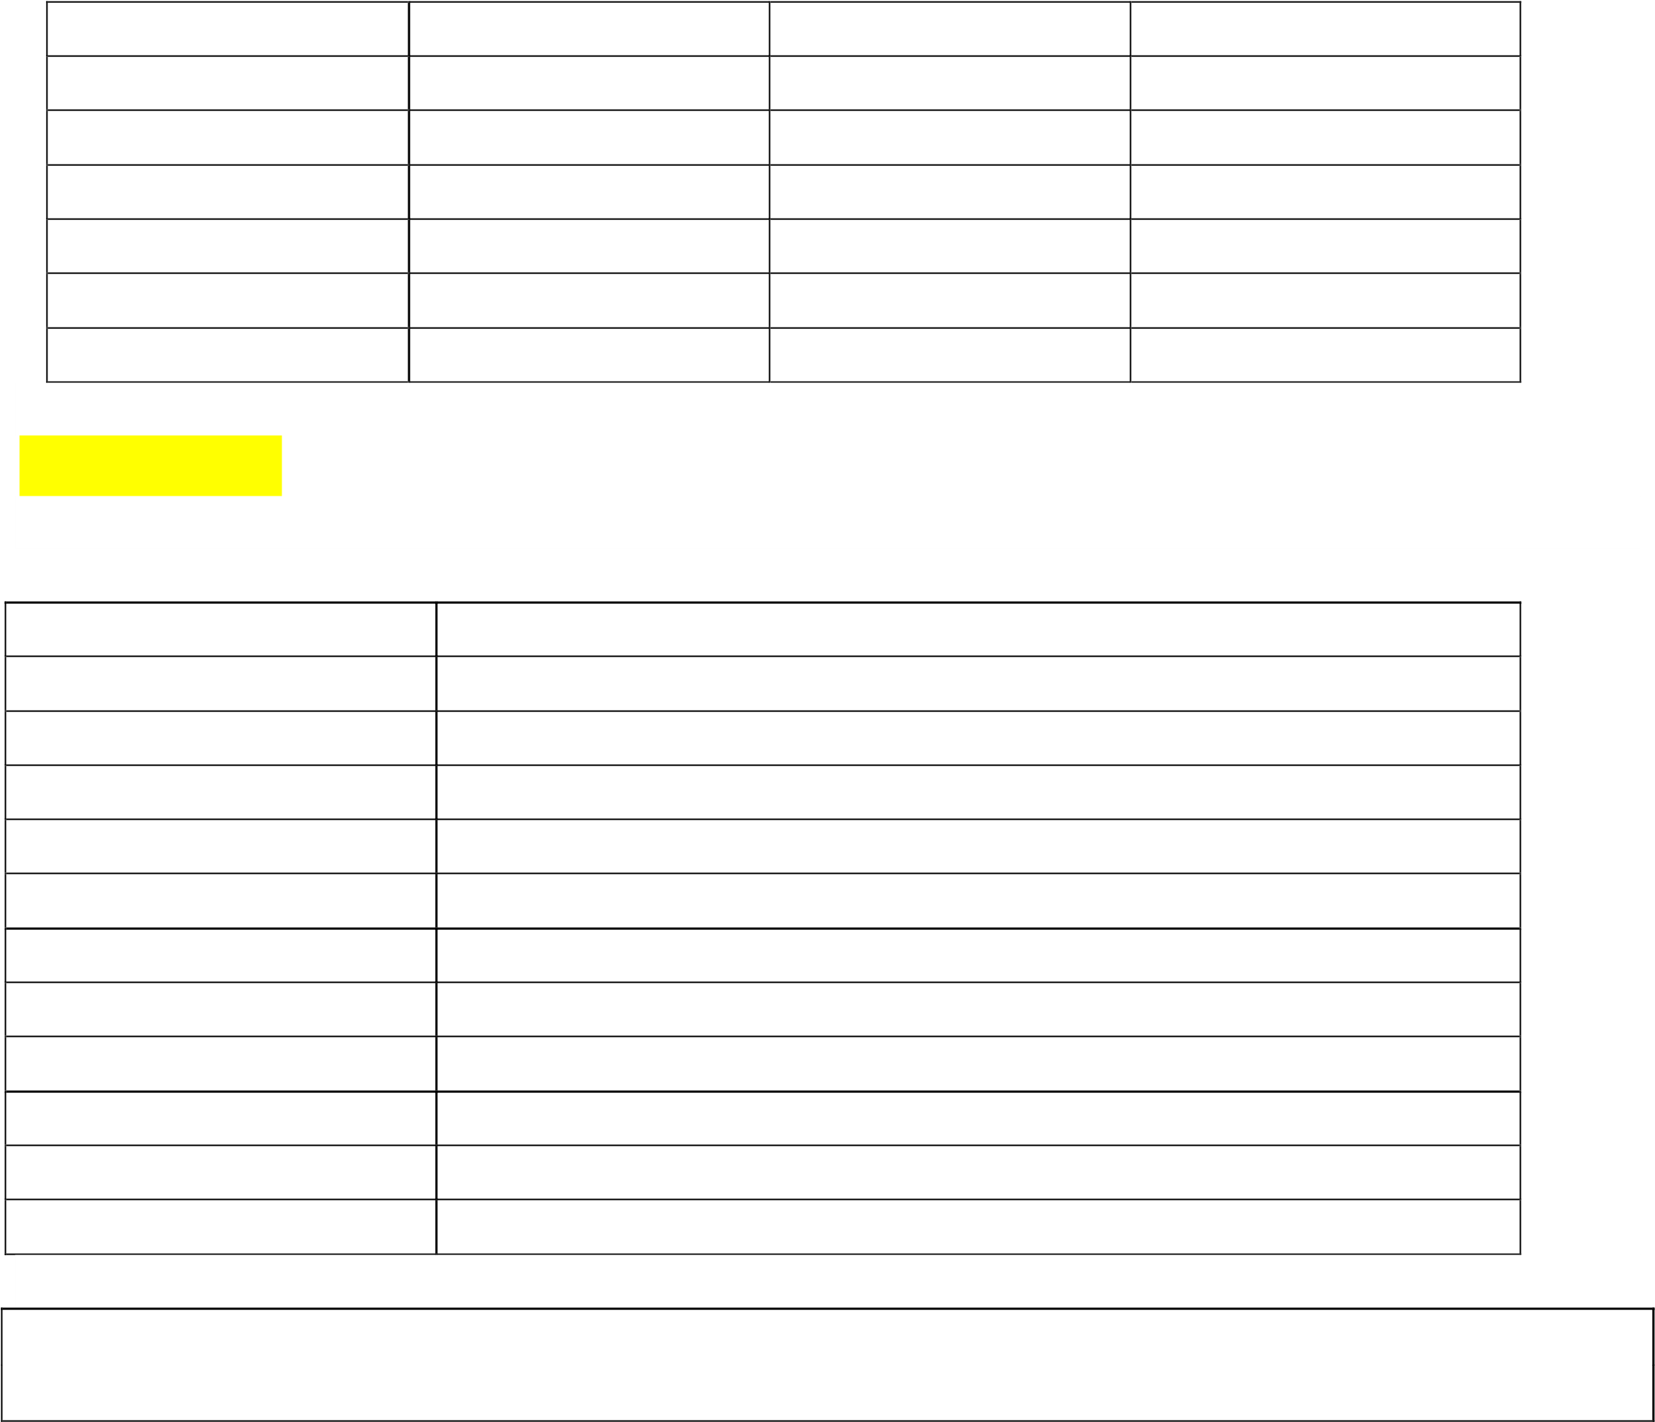

border border-0 border-2 border-4 border-8 border-t border-t-0 border-t-2 border-t-4 border-t-8 border-r border-r-0 border-r-2 border-r-4 border-r-8 border-b border-b-0 border-b-2 border-b-4 border-b-8

border-l border-l-0 border-l-2 border-l-4

border-l-8

#### border-color

This class is used to specify the border color of an element.

**Border Color classes:**

**border-transparent** The border color will be transparent. **border-current** The border will color depend on the parent element color. **border-black**  The border color will be black. **border-white**  The border color will be white. **border-gray-50**  The border color will be gray. **border-red-50**  The border color will be red. **border-blue-50**  The border color will be blue. **border-indigo-50**  The border color will be indigo. **border-purple-50**  The border color will be purple. **border-green-50**  The border color will be green. **border-yellow-50**  The border color will be yellow. **border-pink-50**  The border color will be pink.

**Note:** The color’s values can be changeable according to your need from 50-900, the span should be 100, after the 100.

Example:

<div>

<div class="p-4 mt-1 **border** border-blue-700">Border 1</div>

<div class="p-4 mt-1 **border-2** border-blue-700">Border 2</div>

<div class="p-4 mt-1 **border-4** border-blue-700">Border 4</div>

<div class="p-4 mt-1 **border-8** border-blue-700">Border 8</div> </div> **Output:**

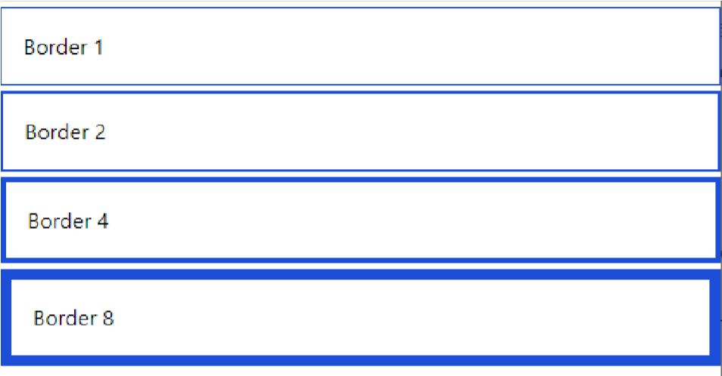

Example: Applying Border Color to Individual Sides

|  |
| --- |
| <div>  <div class="border-4 m-1 border-blue-100 **border-t-blue-700** p-3">border top color</div>  <div class="border-4 m-1 border-blue-100 **border-l-blue-700** p-3">border lfet color</div>  <div class="border-4 m-1 border-blue-100 **border-b-blue-700** p-3">border bottom color</div>  <div class="border-4 m-1 border-blue-100 **border-r-blue-700** p-3">border right color</div>  </div> |

**Output:**

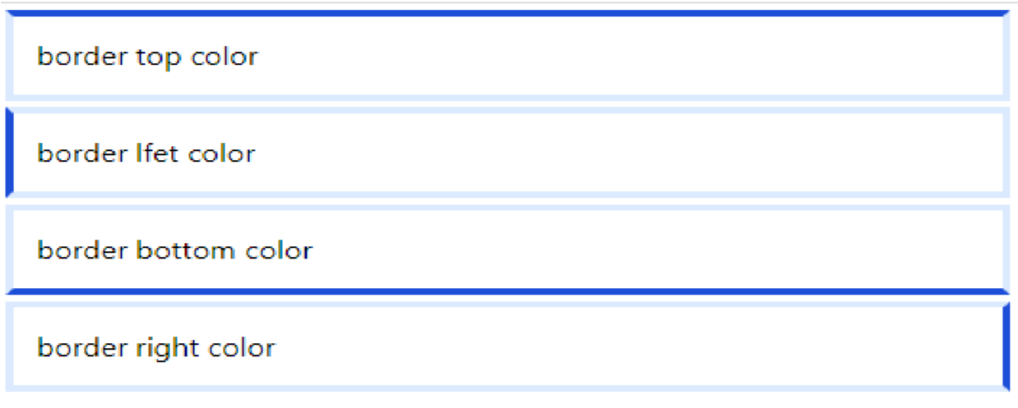

Example: Border color horizontal and vertical sides using border-{x|y}-{color}

<div>

<div class="border-4 m-1 border-blue-100 **border-x-blue-700** p-3">border-x-blue700</div> <br>

<div class="border-4 m-1 border-blue-100 **border-y-blue-700** p-3">border-y-blue700</div>

</div>

**Output:**

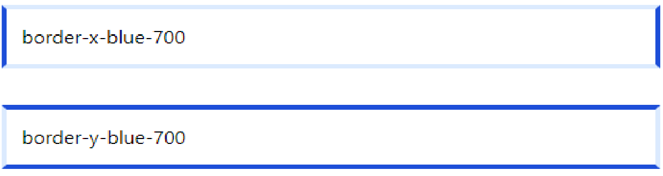

|  |
| --- |
| **border-style** |

This class is used for controlling the style of an element’s borders.

Border Style Classes:

|  |
| --- |
| **border-solid** |
| **border-dashed** |
| **border-dotted** |
| **border-double** |
| **border-none** |
| **border-hidden** |

Example: Border-style

<div class="w-96 **rounded-sm** border-8 border-blue-600 bg-red-400 **border-solid** p-4 m2">rounded-sm</div>

<div class="w-96 **rounded-md** border-8 border-blue-600 bg-yellow-300 **border-double** p4 m-2">rounded-md</div>

<div class="w-96 **rounded-lg** border-8 border-blue-600 bg-blue-300 **border-dashed** p-4 m-2">rounded-lg</div>

<div class="w-96 **rounded-xl** border-8 border-blue-600 bg-pink-300 **border-dotted** p-4 m2">rounded-xl</div>

<div class="w-96 **rounded-2xl** border-8 border-blue-600 bg-green-300 **border-none** p-4 m-2">rounded-2xl</div>

**Output:**

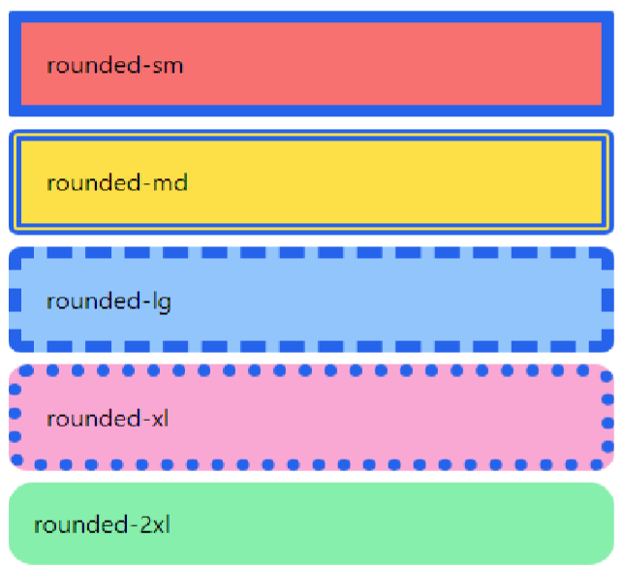

|  |
| --- |
| **border-radius** |

Utilities for controlling the border radius of an element.

Use utilities like rounded-sm, rounded, or rounded-lg to apply different border radius sizes to an element.

|  |  |
| --- | --- |
| **rounded-none** | border-radius: 0px; |
| **rounded-sm** | border-radius: 0.125rem; /* 2px */ |
| **rounded** | border-radius: 0.25rem; /* 4px */ |
| **rounded-md** | border-radius: 0.375rem; /* 6px */ |
| **rounded-lg** | border-radius: 0.5rem; /* 8px */ |
| **rounded-xl** | border-radius: 0.75rem; /* 12px */ |
| **rounded-2xl** | border-radius: 1rem; /* 16px */ |
| **rounded-3xl** | border-radius: 1.5rem; /* 24px */ |
| **rounded-full** | border-radius: 9999px; |

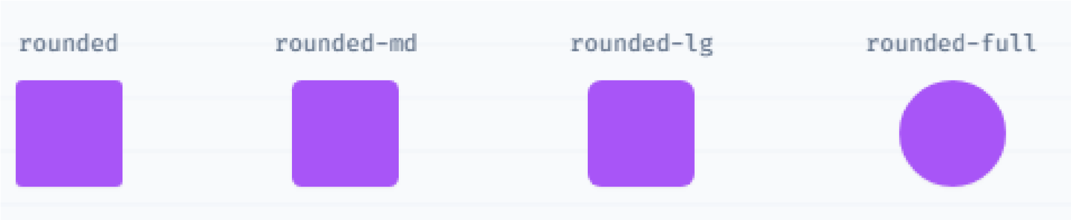

|  |
| --- |
| <div class="w-96 **rounded-sm** border-2 border-blue-600 bg-red-400 p-4 m-2">roundedsm</div>  <div class="w-96 **rounded-md** border-2 border-blue-600 bg-yellow-300 p-4 m2">rounded-md</div>  <div class="w-96 **rounded-lg** border-2 border-blue-600 bg-blue-300 p-4 m-2">roundedlg</div>  <div class="w-96 **rounded-xl** border-2 border-blue-600 bg-pink-300 p-4 m-2">roundedxl</div>  <div class="w-96 **rounded-2xl** border-2 border-blue-600 bg-green-300 p-4 m2">rounded-2xl</div> |

**Output:**

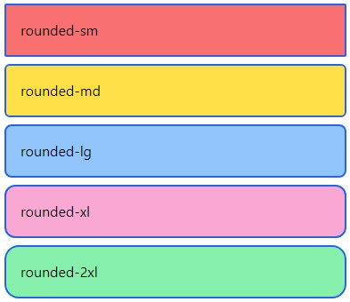

Example: Rounded Corners by Specific Sides

<div class="**rounded-tl-lg** border-blue-600 p-4 **border-[2px]** m-3"> rounded top-left</div>

<div class="**rounded-b-lg** border-blue-600 p-4 **border-[2px]** m-3"> rounded bottom</div>

<div class="**rounded-r-lg** border-blue-600 p-4 **border-[2px]** m-3">

**Output:**

rounded right</div>

<

div class="

**rounded**

**-**

**l**

**-**

**lg**

border

-

blue

-

p

600

-

4

**border**

**-**

**[2**

**px**

**]**

m

-

3

"

>

rounded left</div>

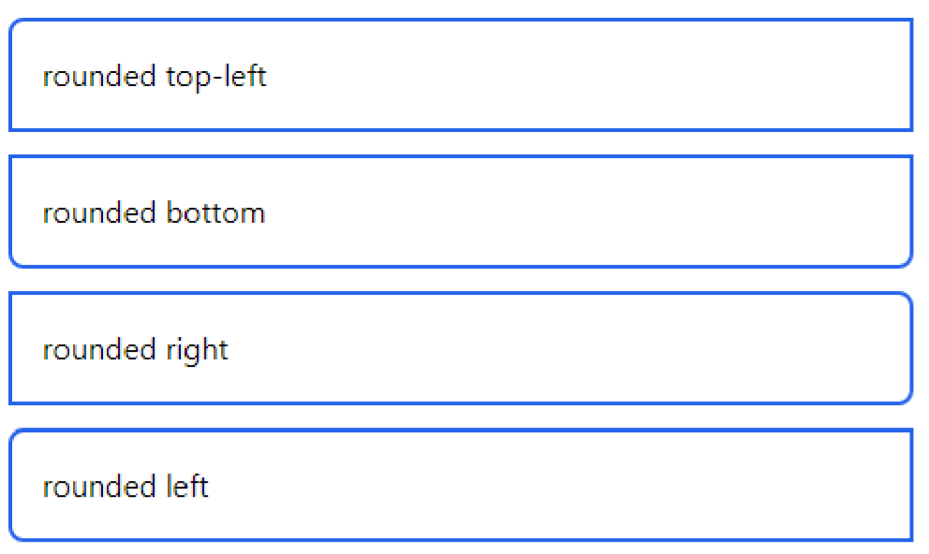

# Layout

|  |
| --- |
| **Container** |

✓ In Tailwind CSS, a container is used to fix the max-width of an element to match the minwidth of the breakpoint. It comes very handy when content has to be displayed in a responsive manner to every breakpoint.

**Breakpoints in tailwind CSS are as follows.**

|  |  |
| --- | --- |
| **Breakpoint** | **min-width** |
| sm | 640px |
| md | 768px |
| lg | 1024px |
| xl | 1280px |
| 2xl | 1536px |

Tailwind CSS does not center itself automatically and also does not contain any pre-defined padding.

**The following are some utility classes that make the container class stand out.**

**mx-auto:** To center the container, we use mx-auto utility class. It adjusts the margin of the container automatically so that the container appears to be in center.

**Syntax:**

<element class=" container mx-auto">...</element>

**px-{size}:** To add padding the container, we use px-{size} utility class. It adds horizontal padding to the container which is equal to the size mentioned.

**Syntax:**

<element class="container px-20">...</element>

Example:

<div class="container mx-auto p-4 bg-pink-200">

<p>Lorem ipsum dolor sit amet, consectetur adipisicing elit. Ut doloribus voluptates soluta corrupti debitis eos nihil beatae vitae, perspiciatis autem, quibusdam amet illum excepturi delectus quidem repellendus commodi velit quae?</p></div>

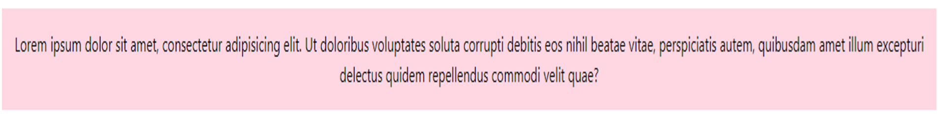

|  |
| --- |
| **Display** |

Utilities for controlling the display box type of an element.

Use inline, inline-block, and block to control the flow of text and elements.

|  |  |
| --- | --- |
| block | display: block; |
| inlineblock | display: inline-block; |
| inline | display: inline; |
| hidden | display: none; |

**Example**

|  |
| --- |
| **<div>**  **When controlling the flow of text, using the CSS property <p class="inline h-24 bg-red-200">display: inline</p>**  **will cause the text inside the element to wrap normally.</div>**  **<div>**  **While using the property**  **<p class="inline-block h-24 bg-yellow-200">display: inline-block</p> will wrap the element to prevent the text inside from extending beyond its parent. </div>**    **<div>**  **Lastly, using the property**  **<span class="block">display: block</span>** **will put the element on its own line and fill its parent.**  **</div>** |

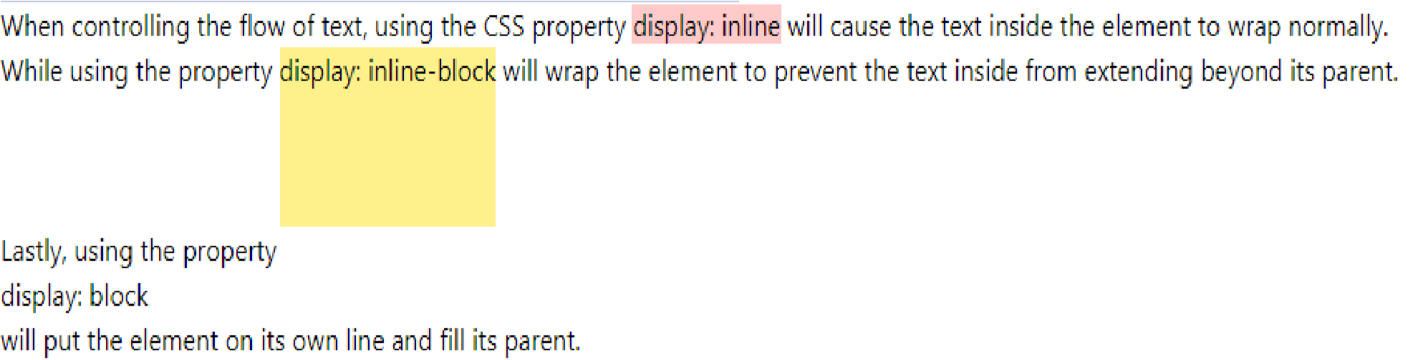

|  |
| --- |
| **Floats** |

Utilities for controlling the wrapping of content around an element.

|  |  |
| --- | --- |
| **float-right** | float: right; |
| **float-left** | float: left; |
| **float-none** | float: none; |

##### Floating elements to the right

Use float-right to float an element to the right of its container.

<div class="m-4 p-4 bg-blue-100 h-40 w-1/2">

<img src="2.png" class="**float-right** px-4 w-48 h-24">

Use float-left to float an element to the left of its container.

<

p class="text

-

xl">Lorem ipsum dolor sit, amet consectetur adipisicing elit. Et perferendis

nesciunt veniam explicabo atque quidem eligendi a fugiat officiis porro autem,

saepe animi

sapiente omnis quasi reprehenderit quis. Consequuntur, minus.</p>

<

/div

>

**Floating elements to the left**

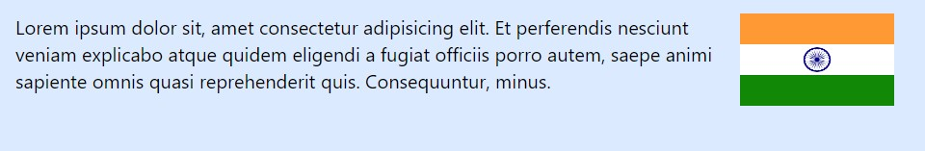

<div class="m-4 p-4 bg-blue-100 h-40 w-1/2">

<img src="2.png" class="**float-left** px-4 w-48 h-24">

<p class="text-xl ">Lorem ipsum dolor sit, amet consectetur adipisicing elit. Et perferendis nesciunt veniam explicabo atque quidem eligendi a fugiat officiis porro autem, saepe animi sapiente omnis quasi reprehenderit quis. Consequuntur, minus.</p> </div>



##### Float None

<div class="m-4 p-4 bg-blue-100 h-52 w-1/2">

<img src="2.png" class="**float-none** px-4 w-48 h-24">

<p class="text-xl ">Lorem ipsum dolor sit, amet consectetur adipisicing elit. Et perferendis nesciunt veniam explicabo atque quidem eligendi a fugiat officiis porro autem, saepe animi sapiente omnis quasi reprehenderit quis. Consequuntur, minus.</p>

</div>

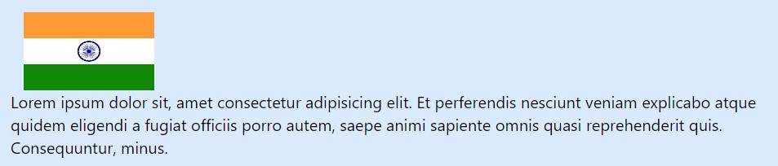

# Effects

|  |
| --- |
| **Box Shadow** |

Utilities for controlling the box shadow of an element.

Use the **shadow-sm, shadow, shadow-md, shadow-lg, shadow-xl, or shadow-2xl** utilities to apply different sized outer box shadows to an element.

**shadow-sm shadow shadow-md shadow-lg shadow-xl shadow-2xl**

Example:

<div class="h-24 w-24 bg-black "></div>

<div class="h-24 w-24 bg-black **shadow-2xl** bg-yellow-200"></div>



|  |
| --- |
| **Box Shadow Color** |

Utilities for controlling the color of a box shadow.

Use the **shadow-{color}** utilities to change the color of an existing box shadow. By default colored shadows have an opacity of 100%, but you can adjust this using the opacity modifier.

|  |  |  |  |  |
| --- | --- | --- | --- | --- |
| shadow-inherit | shadow-current | shadowtransparent | shadow-black | shadow-white |
| shadow-slate50 | shadow-slate100 | shadow-slate200 | shadow-slate300 | shadow-slate400 |
| shadow-slate500 | shadow-slate600 | shadow-slate700 | shadow-slate800 | shadow-slate900 |
| shadow-slate950 | shadow-gray-50 | shadow-gray-100 | shadow-gray200 | shadow-gray300 |
| shadow-gray400 | shadow-gray500 | shadow-gray-600 | shadow-gray700 | shadow-gray800 |
| shadow-gray900 | shadow-gray950 | shadow-zinc-50 | shadow-zinc100 | shadow-zinc200 |
| shadow-zinc300 | shadow-zinc400 | shadow-zinc-500 | shadow-zinc600 | shadow-zinc700 |
| shadow-zinc800 | shadow-zinc900 | shadow-zinc-950 | shadow-  neutral-50 | shadowneutral-100 |
| shadowneutral-200 | shadowneutral-300 | shadow-neutral400 | shadowneutral-500 | shadowneutral-600 |
| shadowneutral-700 | shadowneutral-800 | shadow-neutral900 | shadowneutral-950 | shadow-stone50 |
| shadow-stone100 | shadow-stone200 | shadow-stone300 | shadow-stone400 | shadow-stone500 |
| shadow-stone600 | shadow-stone700 | shadow-stone800 | shadow-stone900 | shadow-stone950 |
| shadow-red-50 | shadow-red100 | shadow-red-200 | shadow-red300 | shadow-red400 |
| shadow-red500 | shadow-red600 | shadow-red-700 | shadow-red800 | shadow-red900 |
| shadow-red950 | shadoworange-50 | shadow-orange100 | shadoworange-200 | shadoworange-300 |
| shadoworange-400 | shadoworange-500 | shadow-orange600 | shadoworange-700 | shadoworange-800 |
| shadoworange-900 | shadoworange-950 | shadow-amber50 | shadow-amber100 | shadow-amber200 |
| shadow-amber300 | shadow-amber400 | shadow-amber500 | shadow-amber600 | shadow-amber700 |
| shadow-amber800 | shadow-amber900 | shadow-amber950 | shadow-yellow50 | shadow-yellow100 |
| shadow-yellow200 | shadow-yellow300 | shadow-yellow400 | shadow-yellow500 | shadow-yellow600 |
| shadow-yellow700 | shadow-yellow800 | shadow-yellow900 | shadow-yellow950 | shadow-lime-50 |
| shadow-lime100 | shadow-lime200 | shadow-lime-300 | shadow-lime400 | shadow-lime500 |
| shadow-lime600 | shadow-lime700 | shadow-lime-800 | shadow-lime900 | shadow-lime950 |
| shadow-green50 | shadow-green100 | shadow-green200 | shadow-green300 | shadow-green400 |
| shadow-green500 | shadow-green600 | shadow-green700 | shadow-green800 | shadow-green900 |
| shadow-green950 | shadowemerald-50 | shadowemerald-100 | shadowemerald-200 | shadowemerald-300 |
| shadowemerald-400 | shadowemerald-500 | shadowemerald-600 | shadowemerald-700 | shadowemerald-800 |
| shadowemerald-900 | shadowemerald-950 | shadow-teal-50 | shadow-teal100 | shadow-teal200 |
| shadow-teal300 | shadow-teal400 | shadow-teal-500 | shadow-teal600 | shadow-teal700 |
| shadow-teal800 | shadow-teal900 | shadow-teal-950 | shadow-cyan50 | shadow-cyan100 |
| shadow-cyan200 | shadow-cyan300 | shadow-cyan400 | shadow-cyan500 | shadow-cyan600 |
| shadow-cyan700 | shadow-cyan800 | shadow-cyan900 | shadow-cyan950 | shadow-sky-50 |
| shadow-sky100 | shadow-sky200 | shadow-sky-300 | shadow-sky400 | shadow-sky500 |
| shadow-sky600 | shadow-sky700 | shadow-sky-800 | shadow-sky900 | shadow-sky950 |
| shadow-blue-50 | shadow-blue100 | shadow-blue-200 | shadow-blue300 | shadow-blue400 |
| shadow-blue500 | shadow-blue600 | shadow-blue-700 | shadow-blue800 | shadow-blue900 |
| shadow-blue950 | shadow-indigo50 | shadow-indigo100 | shadow-indigo200 | shadow-indigo300 |
| shadow-indigo400 | shadow-indigo500 | shadow-indigo600 | shadow-indigo700 | shadow-indigo800 |
| shadow-indigo900 | shadow-indigo950 | shadow-violet-50 | shadow-violet100 | shadow-violet200 |
| shadow-violet300 | shadow-violet400 | shadow-violet500 | shadow-violet600 | shadow-violet700 |
| shadow-violet800 | shadow-violet900 | shadow-violet950 | shadow-purple50 | shadow-purple100 |
| shadow-purple200 | shadow-purple300 | shadow-purple400 | shadow-purple500 | shadow-purple600 |
| shadow-purple700 | shadow-purple800 | shadow-purple900 | shadow-purple950 | shadow-  fuchsia-50 |
| shadow-  fuchsia-100 | shadow-  fuchsia-200 | shadow-fuchsia300 | shadow-  fuchsia-400 | shadow-  fuchsia-500 |
| shadow-  fuchsia-600 | shadow-  fuchsia-700 | shadow-fuchsia800 | shadow-  fuchsia-900 | shadow-  fuchsia-950 |
| shadow-pink-50 | shadow-pink100 | shadow-pink-200 | shadow-pink300 | shadow-pink400 |
| shadow-pink500 | shadow-pink600 | shadow-pink-700 | shadow-pink800 | shadow-pink900 |
| shadow-pink950 | shadow-rose-50 | shadow-rose-100 | shadow-rose200 | shadow-rose300 |
| shadow-rose400 | shadow-rose500 | shadow-rose-600 | shadow-rose700 | shadow-rose800 |
| shadow-rose900 | shadow-rose950 |  |  |  |

# Flexbox

* The CSS flexbox is a vital feature to develop the frontend.
* It is the alternative of CSS flex Property for fast development of front-end. It is used to set the length of flexible items. The flex class is much responsive and mobile-friendly.

### Display

**flex:** It is used to display an element as a **block-level** flex container.

|  |
| --- |
| <div class="**flex** p-3 bg-blue-300 text-white">  <div class="p-2 bg-red-400">Flex item 1</div>  <div class="p-2 bg-yellow-400">Flex item 2</div>  <div class="p-2 bg-green-300">Flex item 3</div> </div> |



**inline-flex:** It is used to display an element as an **inline-level** flex container.

|  |
| --- |
| <div class="**inline-flex** p-3 bg-blue-300 text-white"> <div class="p-2 bg-red-400">Flex item 1</div>  <div class="p-2 bg-yellow-400">Flex item 2</div>  <div class="p-2 bg-green-300">Flex item 3</div> </div> |

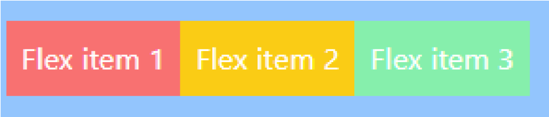

### Flex Direction

Utilities for controlling the direction of flex items. **flex-row** flex-direction: row;

**flex-row-reverse** flex-direction: row-reverse; **flex-col** flex-direction: column;

**flex-col-reverse** flex-direction: column-reverse;

Row

Use **flex-row** to position flex items horizontally in the same direction as text:

|  |
| --- |
| <div class="w-1/2 **flex flex-row** bg-black p-4">  <div class="p-2 bg-red-400">Flex item 1</div>  <div class="p-2 bg-yellow-400">Flex item 2</div>  <div class="p-2 bg-green-300">Flex item 3</div> </div> |



###### Row reversed

Use **flex-row-reverse** to position flex items horizontally in the opposite direction:

|  |
| --- |
| <div class="w-1/2 **flex flex-row-reverse** bg-black p-4">  <div class="p-2 bg-red-400">Flex item 1</div>  <div class="p-2 bg-yellow-400">Flex item 2</div>  <div class="p-2 bg-green-300">Flex item 3</div> </div> |



###### Column

Use **flex-col** to position flex items vertically:

|  |
| --- |
| <div class="m-4 **inline-flex flex-col** bg-black p-4">  <div class="p-2 bg-red-400">Flex item 1</div>  <div class="p-2 bg-yellow-400">Flex item 2</div>  <div class="p-2 bg-green-300">Flex item 3</div> </div> |

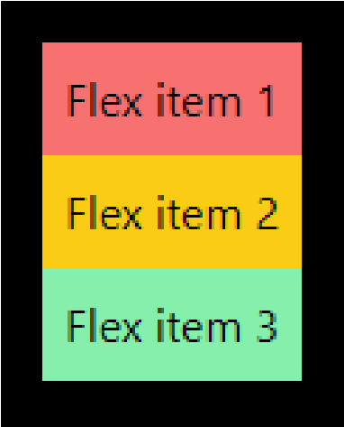

###### Column reversed

Use **flex-col-reverse** to position flex items vertically in the opposite direction:

|  |
| --- |
| <div class="**inline-flex flex-col-reverse** bg-black p-4">  <div class="p-2 bg-red-400">Flex item 1</div>  <div class="p-2 bg-yellow-400">Flex item 2</div>  <div class="p-2 bg-green-300">Flex item 3</div> </div> |

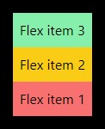

### Flex wrap

###### Wrap

Use **.flex-wrap** to allow flex items to wrap:

|  |
| --- |
| <div class="m-24 w-1/4 **flex flex-wrap** bg-green-200 p-4 text-center text-lg">  <div class="bg-green-900 w-24 h-12">1</div>  <div class="bg-green-800 w-24 h-12">2</div>  <div class="bg-green-700 w-24 h-12">3</div>  <div class="bg-green-600 w-24 h-12">4</div>  <div class="bg-green-500 w-24 h-12">5</div>  <div class="bg-green-400 w-24 h-12">6</div> </div> |

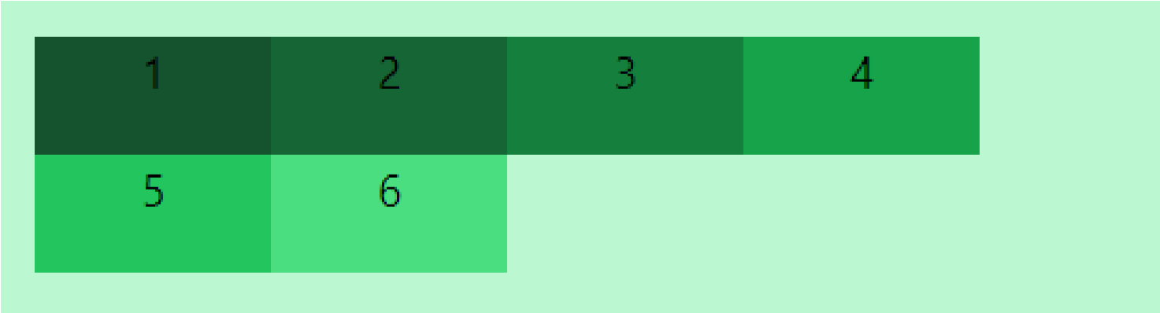

###### No Wrap

Use **.flex-no-wrap** to prevent flex items from wrapping, causing inflexible items to overflow the container if necessary:

|  |
| --- |
| <div class="m-24 w-1/4 **flex flex-no-wrap** bg-red-200 p-4 text-center text-xl">  <div class="bg-red-900 w-24 h-12">1</div>  <div class="bg-red-800 w-24 h-12">2</div>  <div class="bg-red-700 w-24 h-12">3</div>  <div class="bg-red-600 w-24 h-12">4</div>  <div class="bg-red-500 w-24 h-12">5</div>  <div class="bg-red-400 w-24 h-12">6</div> </div> |

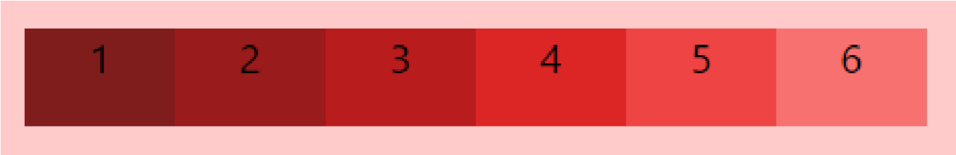

<div class="m-24 w-1/4 **flex flex-no-wrap** bg-red-200 p-4 text-center text-xl">

<div class="**flex-none** bg-red-900 w-24 h-12">1</div>

<div class="**flex-none** bg-red-800 w-24 h-12">2</div>

<div class="**flex-none** bg-red-700 w-24 h-12">3</div>

<div class="**flex-none** bg-red-600 w-24 h-12">4</div>

<div class="**flex-none** bg-red-500 w-24 h-12">5</div>

<div class="**flex-none** bg-red-400 w-24 h-12">6</div>

###### Wrap reversed

Use **.flex-wrap-reverse** to wrap flex items in the reverse direction:

<

/div

>

**Note:**

Use

**flex**

-

**none**

to prevent a flex item from growing or shrinking

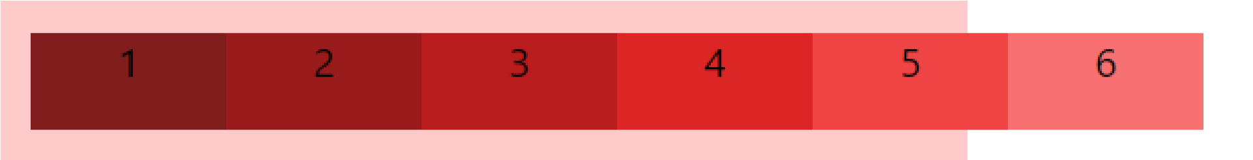

<div class="m-24 w-1/4 **flex flex-wrap-reverse** bg-blue-200 p-4 text-center text-xl">

<div class="bg-blue-900 w-24 h-12">1</div>

<div class="bg-blue-800 w-24 h-12">2</div>

<div class="bg-blue-700 w-24 h-12">3</div>

<div class="bg-blue-600 w-24 h-12">4</div>

<div class="bg-blue-500 w-24 h-12">5</div>

<div class="bg-blue-400 w-24 h-12">6</div>

</div>

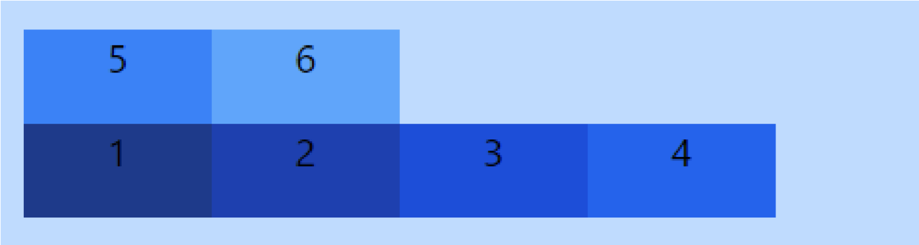

# Box Alignment

### Justify Content

Utilities for controlling how flex and grid items are positioned along a container's main axis.

|  |  |
| --- | --- |
| **justify-start** | justify-content: flex-start; |
| **justify-end** | justify-content: flex-end; |
| **justify-center** | justify-content: center; |
| **justify-between** | justify-content: space-between; |
| **justify-around** | justify-content: space-around; |
| **justify-evenly** | justify-content: space-evenly; |

##### Start

Use **justify-start** to justify items against the start of the container’s main axis:

<div class="w-1/2 flex **justify-start** bg-black p-4 m-4">

<div class="p-2 bg-red-400">Flex item 1</div>

<div class="p-2 bg-yellow-400">Flex item 2</div>

<div class="p-2 bg-green-300">Flex item 3</div>

</div>



##### Center

Use **justify-center** to justify items along the center of the container’s main axis:

<div class="w-1/2 flex **justify-center** bg-black p-4 m-4">

<div class="p-2 bg-red-400">Flex item 1</div>

<div class="p-2 bg-yellow-400">Flex item 2</div>

<div class="p-2 bg-green-300">Flex item 3</div>

</div>



##### End

Use **justify-end** to justify items against the end of the container’s main axis:

<div class="w-1/2 flex **justify-end** bg-black p-4 m-4">

<div class="p-2 bg-red-400">Flex item 1</div>

<div class="p-2 bg-yellow-400">Flex item 2</div>

<div class="p-2 bg-green-300">Flex item 3</div>

</div>



##### Space between

Use **justify-between** to justify items along the container’s main axis such that there is an equal amount of space between each item:

<div class="w-1/2 flex **justify-between** bg-black p-4 m-4">

<div class="p-2 bg-red-400">Flex item 1</div>

<div class="p-2 bg-yellow-400">Flex item 2</div>

<div class="p-2 bg-green-300">Flex item 3</div>

</div>



##### Space around

Use **justify-around** to justify items along the container’s main axis such that there is an equal amount of space on each side of each item:

<div class="w-1/2 flex **justify-around** bg-black p-4 m-4">

<div class="p-2 bg-red-400">Flex item 1</div>

<div class="p-2 bg-yellow-400">Flex item 2</div>

<div class="p-2 bg-green-300">Flex item 3</div>

</div>



##### Space evenly

Use **justify-evenly** to justify items along the container’s main axis such that there is an equal amount of space around each item, but also accounting for the doubling of space you would normally see between each item when using justify-around:

<div class="w-1/2 flex **justify-evenly** bg-black p-4 m-4">

<div class="p-2 bg-red-400">Flex item 1</div>

<div class="p-2 bg-yellow-400">Flex item 2</div>

<div class="p-2 bg-green-300">Flex item 3</div>

</div>



### Justify Items

This class accepts two values in tailwind CSS. It is the alternative to the CSS justify-items property. This class is used for controlling how grid items are aligned along their inline axis.

Justify Items:

**justify-items-auto justify-items-start justify-items-end justify-items-center justify-items-stretch**

**justify-items-auto:** This class is used to justify grid items automatically on their inline axis.

**<element class="justify-items-auto">...</element>**

Example:

|  |
| --- |
| <div id="main" class="w-1/2 grid **justify-items-auto** grid-cols-3 bg-black m-4">  <div class="bg-green-500 rounded-lg m-4 h-12">1</div>  <div class="bg-green-500 rounded-lg m-4 h-12">2</div>  <div class="bg-green-500 rounded-lg m-4 h-12">3</div>  <div class="bg-green-500 rounded-lg m-4 h-12">4</div>  <div class="bg-green-500 rounded-lg m-4 h-12">5</div> <div class="bg-green-500 rounded-lg m-4 h-12">6</div>  </div> |

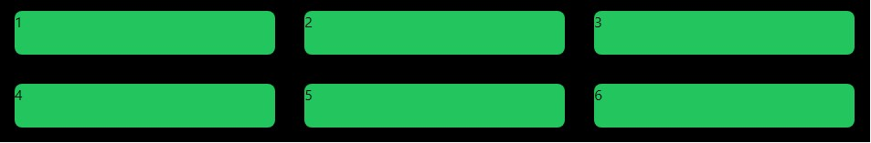

**justify-items-start:** This class is used to justify grid items against the start of their inline axis.

**<element class="justify-items-start">...</element>**

Example:

<div id="main" class="w-1/2 grid **justify-items-start** grid-cols-3 bg-black m-4">

<div class="bg-green-500 rounded-lg m-4 h-12 w-24">1</div>

<div class="bg-green-500 rounded-lg m-4 h-12 w-24">2</div>

<div class="bg-green-500 rounded-lg m-4 h-12 w-24">3</div>

<div class="bg-green-500 rounded-lg m-4 h-12 w-24">4</div>

**justify-items-end:** This class is used to justify grid items against the end of their inline axis.

div class="bg

<

-

green

-

500

rounded

-

lg m

-

4

h

-

12

w

-

24

">5</div>

<

div class="bg

-

green

-

500

rounded

-

lg m

-

h

4

-

1

w

2

-

24

">6</div>

<

/div>

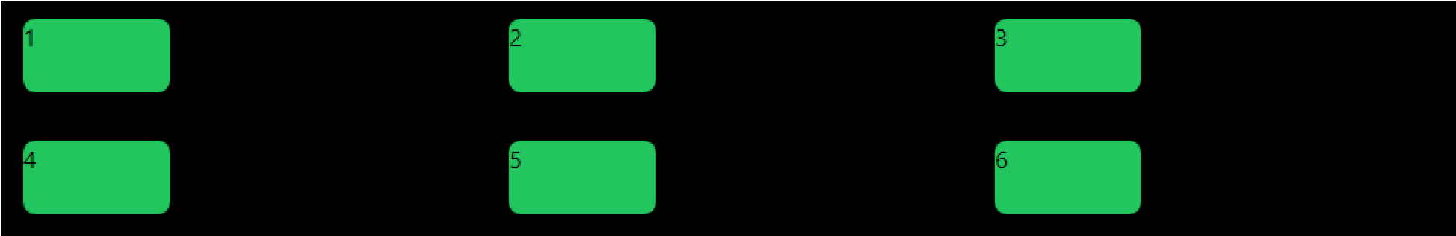

**<element class="justify-items-end">...</element>**

Example:

|  |
| --- |
| <div id="main" class="w-1/2 grid **justify-items-end** grid-cols-3 bg-black m-4">  <div class="bg-green-500 rounded-lg m-4 h-12 w-24">1</div>  <div class="bg-green-500 rounded-lg m-4 h-12 w-24">2</div>  <div class="bg-green-500 rounded-lg m-4 h-12 w-24">3</div>  <div class="bg-green-500 rounded-lg m-4 h-12 w-24">4</div>  <div class="bg-green-500 rounded-lg m-4 h-12 w-24">5</div> <div class="bg-green-500 rounded-lg m-4 h-12 w-24">6</div>  </div> |

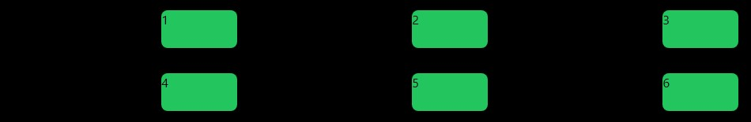

**justify-items-center:** This class is used to justify grid items along their inline axis.

**<element class="jjustify-items-center">...</element>**

Example:

|  |
| --- |
| <div id="main" class="w-1/2 grid **justify-items-center** grid-cols-3 bg-black m-4">  <div class="bg-green-500 rounded-lg m-4 h-12 w-24">1</div>  <div class="bg-green-500 rounded-lg m-4 h-12 w-24">2</div>  <div class="bg-green-500 rounded-lg m-4 h-12 w-24">3</div>  <div class="bg-green-500 rounded-lg m-4 h-12 w-24">4</div>  <div class="bg-green-500 rounded-lg m-4 h-12 w-24">5</div> <div class="bg-green-500 rounded-lg m-4 h-12 w-24">6</div>  </div> |

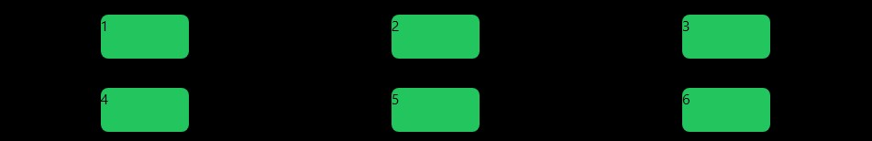

**justify-items-stretch:** This class is used to stretch items along their inline axis.

**<element class="justify-items-stretch">...</element>**

Example:

<div id="main" class="w-1/2 grid **justify-items-stretch** grid-cols-3 bg-black m-4">

<div class="bg-green-500 rounded-lg m-4 h-12">1</div>

<div class="bg-green-500 rounded-lg m-4 h-12">2</div>

<div class="bg-green-500 rounded-lg m-4 h-12">3</div>

<div class="bg-green-500 rounded-lg m-4 h-12">4</div>

<div class="bg-green-500 rounded-lg m-4 h-12">5</div>

<div class="bg-green-500 rounded-lg m-4 h-12">6</div>

</div>

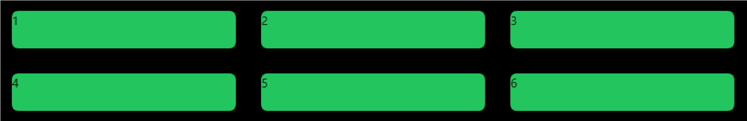

# Grid

### Grid Template Columns

It is used to set the number of columns and size of the columns of the grid, here we will do the same but for fast development of front-end. The number of columns is set by the number of values given to this class.

|  |  |
| --- | --- |
| **grid-cols-1** | Each row concedes only one column. |
| **grid-cols-2** | Each row concedes only two columns. |
| **grid-cols-3** | Each row concedes only three columns. |
| **grid-cols-4** | Each row concedes only four columns. |
| **grid-cols-5** | Each row concedes only five columns. |
| **grid-cols-6** | Each row concedes six columns. |
| **grid-cols-7** | Each row concedes seven-columns. |
| **grid-cols-8** | Each row concedes eight columns. |
| **grid-cols-9** | Each row concedes nine columns. |
| **grid-cols-10** | Each row concedes ten columns. |
| **grid-cols-11** | Each row concedes eleven columns. |
| **grid-cols-12** | Each row concedes twelve columns. |
| **grid-cols-none** | Does not follow the grid-column property. |

**Syntax:**

<element class="**grid grid-cols-number**"> Contents... </element>

### Gap

Utilities for controlling gutters between grid and flexbox items.

|  |  |  |  |  |
| --- | --- | --- | --- | --- |
| gap-0 | gap-x-0 | gap-y-0 | gap-px | gap-x-px |
| gap-y-px | gap-0.5 | gap-x-0.5 | gap-y-0.5 | gap-1 |
| gap-x-1 | gap-y-1 | gap-1.5 | gap-x-1.5 | gap-y-1.5 |
| gap-2 | gap-x-2 | gap-y-2 | gap-2.5 | gap-x-2.5 |
| gap-y-2.5 | gap-3 | gap-x-3 | gap-y-3 | gap-3.5 |
| gap-x-3.5 | gap-y-3.5 | gap-4 | gap-x-4 | gap-y-4 |
| gap-5 | gap-x-5 | gap-y-5 | gap-6 | gap-x-6 |
| gap-y-6 | gap-7 | gap-x-7 | gap-y-7 | gap-8 |
| gap-x-8 | gap-y-8 | gap-9 | gap-x-9 | gap-y-9 |
| gap-10 | gap-x-10 | gap-y-10 | gap-11 | gap-x-11 |
| gap-y-11 | gap-12 | gap-x-12 | gap-y-12 | gap-14 |
| gap-x-14 | gap-y-14 | gap-16 | gap-x-16 | gap-y-16 |
| gap-20 | gap-x-20 | gap-y-20 | gap-24 | gap-x-24 |
| gap-y-24 | gap-28 | gap-x-28 | gap-y-28 | gap-32 |
| gap-x-32 | gap-y-32 | gap-36 | gap-x-36 | gap-y-36 |
| gap-40 | gap-x-40 | gap-y-40 | gap-44 | gap-x-44 |
| gap-y-44 | gap-48 | gap-x-48 | gap-y-48 | gap-52 |
| gap-x-52 | gap-y-52 | gap-56 | gap-x-56 | gap-y-56 |
| gap-60 | gap-x-60 | gap-y-60 | gap-64 | gap-x-64 |
| gap-y-64 | gap-72 | gap-x-72 | gap-y-72 | gap-80 |
| gap-x-80 | gap-y-80 | gap-96 | gap-x-96 | gap-y-96 |

Example:

|  |
| --- |
| <div id="main" class="**grid grid-cols-4 gap-2** p-4">  <div class="bg-green-300 h-12">1</div>  <div class="bg-green-500 h-12">2</div>  <div class="bg-green-300 h-12">3</div>  <div class="bg-green-500 h-12">4</div>  <div class="bg-green-300 h-12">5</div>  <div class="bg-green-500 h-12">6</div> </div> |



**Tailwind modifiers**

### Pseudo-classes like :hover, :focus, :active, :visited

* Tailwind CSS uses the hover, focus, active, visited variants to style an element when the user mouse move over it, focuses it, actively clicks/tapped it and visited it.
* These variants allow you to create interactive and dynamic user interfaces without writing custom CSS.

**Below are examples of several pseudo-class states supported in Tailwind CSS.**

* 1. **Hover:** The hover variant is used to style an element when the user hovers the mouse pointer over it. The modifier used is **hover:**
     1. For example, you can use the **hover:bg-red-500** class to change the background color of an element to red when the user hovers the mouse over it.

* 1. **Focus:** Applied when an element has the focus. It is also enabled by default in Tailwind CSS. The modifier used is **focus:**
     1. For example, you can use the **focus:bg-red-500** class to change the background color of an element to red when an element has the focus.

* 1. **Active:** Applied when an element is being activated by the user. The modifier used is **active:** 
     1. For example, you can use the **active:bg-red-500** class to change the background color of an element to red when an element is being activated by the user.

* 1. **Visited:** Applied once a user has visited a link. The modifier used is **visited:** 
     1. For example, you can use the **visited:bg-red-500** class to change the background color of an element to red when a user has visited a link.

Example to understand pseudo class

<head><script src="https://cdn.tailwindcss.com"></script></head>

<body>

<a href="#" class="**bg-pink-900** p-4 px-4 text-white m-4 **hover:bg-black** **active:bg-red-500** **visited:bg-yellow-500** **focus:bg-green-600**">Click here to check effects</a>

</body>

**Output**

Initially

After Hover

Active

Focus

Visited

**Pseudo**

**-**

**elements like ::before , ::after, ::first**

**-**

**line**

**, ::first**

**-**

**letter**

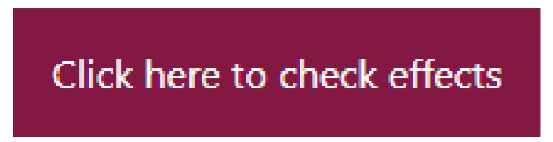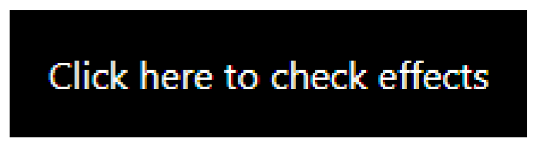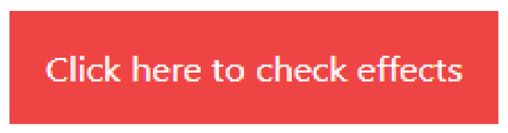

Use the **content-{value}** utilities along with the before and after variant modifiers to set the contents of the ::before and ::after pseudo-elements.

**Before ::before**

* This pseudo-element ::before allows us to add content before an element. It's like having a virtual container right before the actual content of an element.
* By using the ::before pseudo-element, we can insert content before the actual content of an element.

**After ::after**

* Similar to ::before, Pseudo-element ::after allows us to add content after an element. It's like having a virtual container right after the actual content of an element.
* By using the ::after pseudo-element, we can insert content after the actual content of an element.

This way, we can add extra visual elements or important information to our web page without modifying the original HTML structure.

**Here's a simple example of Tailwind CSS code for the ::after and ::before utilities:**

**First Letter ::first-letter**

* The ::first-letter pseudo-element allows you to style the first letter of a block of text or a paragraph in a unique way.

<

p

class="text

-

m

xl

7

-

4

**before**

:

content

-

'before']

[

**before**

text

:

-

green

-

500

**after**

content

:

-

[

'Hello']

**after**

:

text

-

red

-

500

**after**

:

text

-

5

xl"> Lorem ipsum dolor sit amet </p

>

**Output:**



* It can be used to make the first letter bigger, apply a different font, change its color, or add decorative elements to enhance the visual appeal.
* This way, you can easily customize the initial letter without altering the rest of the text.

**First Line ::first-line**

* The ::first-line pseudo-element allows you to style the first line of a block of text or a paragraph separately.
* It's like having a special focus on the first line of your content.

**Here's a simple example of Tailwind CSS code for the ::first-letter and ::first-line utilities:**

<p class="p-4 **first-line:**uppercase **first-line:**font-bold **first-letter**:text-9xl **first-letter**:textred-500 **first-line:**text-blue-400 text-3xl">

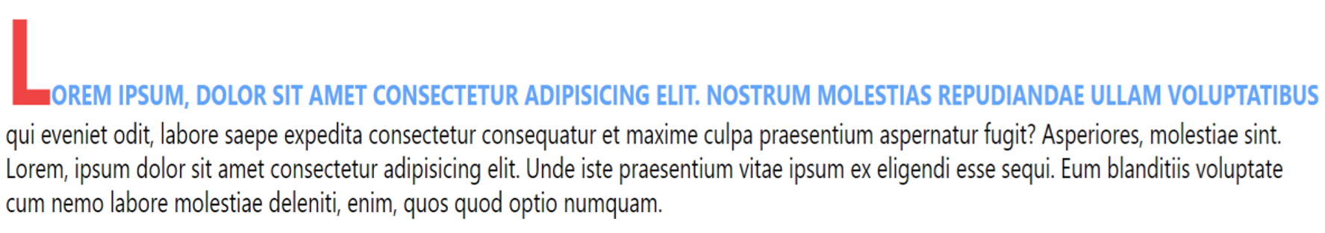

Lorem ipsum, dolor sit amet consectetur adipisicing elit. Nostrum molestias repudiandae ullam voluptatibus qui eveniet odit, labore saepe expedita consectetur consequatur et maxime culpa praesentium aspernatur fugit? Asperiores, molestiae sint. Lorem, ipsum dolor sit amet consectetur adipisicing elit. Unde iste praesentium vitae ipsum ex eligendi esse sequi. Eum blanditiis voluptate cum nemo labore molestiae deleniti, enim, quos quod optio numquam.

**Referencing an attribute value**

</p>

**Output:**

These content utilities even support CSS features like the attr() function, which you can use to reference a value stored in an attribute:

Example:

**<div before="Hello World" class="before:content-[attr(before)]"></div> Output: Hello World**

**Using spaces and underscores**

Since whitespace denotes the end of a class in HTML, replace any spaces in an arbitrary value with an underscore:

Example:

**<div class="before:content-['Hello_World']"></div>**

**Output: Hello World**

If you need to include an actual underscore, you can do this by escaping it with a backslash:

Example:

**<div class="before:content-['Hello\_World']"></div>**

**Output: Hello_World**

# Transitions and Animation

|  |
| --- |
| **transition-property** |

* Utilities for controlling which CSS properties transition.
* **Controlling transitioned properties**
* Use the **transition-{properties}** utilities to specify which properties should transition when they change.

|  |  |
| --- | --- |
| **Tailwind class** | **CSS Property** |
| **transition-none** | transition-property: none; |
| **transition-all** | transition-property: all; |
| **transition** | transition-property: color, backgroundcolor, border-color, text-decorationcolor, fill, stroke, opacity, box-shadow, transform, filter, backdrop-filter; |
| **transition-colors** | transition-property: color, backgroundcolor, border-color, text-decorationcolor, fill, stroke; |
| **transition-shadow** | transition-property: box-shadow; |

|  |
| --- |
| **transition-duration** |

* Utilities for controlling the duration of CSS transitions.
* **Changing transition duration**
* Use the **duration-{amount}** utilities to control an element’s transition-duration.

|  |  |
| --- | --- |
| **Tailwind class** | **CSS Property** |
| **duration-0** | transition-duration: 0s; |
| **duration-75** | transition-duration: 75ms; |
| **duration-100** | transition-duration: 100ms; |
| **duration-150** | transition-duration: 150ms; |
| **duration-200** | transition-duration: 200ms; |
| **duration-300** | transition-duration: 300ms; |
| **duration-500** | transition-duration: 500ms; |
| **duration-700** | transition-duration: 700ms; |
| **duration-1000** | transition-duration: 1000ms; |

|  |
| --- |
| **transition-delay** |

* Utilities for controlling the delay of CSS transitions.
* Delaying transitions
* Use the **delay-{amount}** utilities to control an element’s transition-delay.

|  |  |
| --- | --- |
| **Tailwind class** | **CSS Property** |
| **delay-0** | transition- delay: 0s; |
| **delay-75** | transition- delay: 75ms; |
| **delay-100** | transition- delay: 100ms; |
| **delay-150** | transition- delay: 150ms; |
| **delay-200** | transition- delay: 200ms; |
| **delay-300** | transition- delay: 300ms; |
| **delay-500** | transition- delay: 500ms; |
| **delay-700** | transition- delay: 700ms; |
| **delay-1000** | transition- delay: 1000ms; |

Example:

<button class="px-10 py-4 bg-black text-white my-11 mx-4 text-2xl **hover:px-11 hover:py-5 hover:text-black hover:bg-white hover:border-2 hover:border-black** rounded-md **delay1000** **transition-all** **duration-1000**">Click Here</button>

|  |
| --- |
| **animation** |

**Utilities for animating elements with CSS animations.**

**Spin**

Add the animate-spin utility to add a linear spin animation to elements **like loading indicators**. **Ping**

Add the animate-ping utility to make an element scale and fade like a **radar ping or ripple of water** — useful for things like **notification badges**.

**Pulse**

Add the animate-pulse utility to make an element gently fade in and out — useful for things like skeleton loaders. **Bounce**

Add the animate-bounce utility to make an element bounce up and down — useful for things like “**scroll down**” indicators.

Example:

<div class="p-4 m-4"></div>

<div class="w-32 m-auto h-32 rounded-full bg-blue-500 **animate-bounce** text-white p4">Bounce</div>

<div class="w-32 m-auto h-32 bg-red-500 **animate-spin** text-white p-4">Spin</div>

<div class="w-32 h-32 m-auto bg-green-500 **animate-pulse** text-white p-4">Pulse</div> <div class="p-5 m-5"></div>

<div class="w-32 m-auto h-32 bg-purple-500 **animate-ping** text-white p-4">Ping</div>

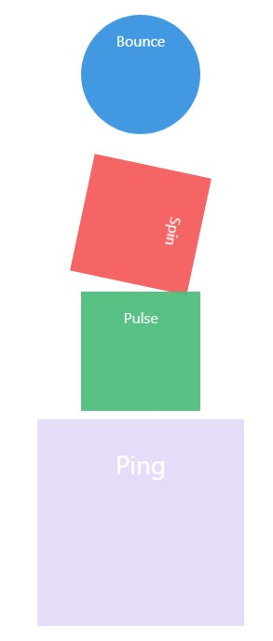

# Responsive Design

Using responsive utility variants to build adaptive user interfaces.

* Every utility class in Tailwind can be applied conditionally at different breakpoints, which makes it a piece of cake to build complex responsive interfaces without ever leaving your HTML.
* Without below line, a website might not display correctly on mobile devices, often causing the content to be too large or too small to read easily.

**<head><meta name="viewport" content="width=device-width, initial-scale=1.0"></head>** There are five breakpoints by default, inspired by common device resolutions:

|  |  |  |
| --- | --- | --- |
| Breakpoint prefix | Minimum width | CSS |
| sm | 640px | @media(min-width: 640px){ ... } |
| md | 768px | @media(min-width: 768px){ ... } |
| lg | 1024px | @media (min-width: 1024px){ ... } |
| xl | 1280px | @media (min-width: 1280px){ ... } |
| 2xl | 1536px | @media (min-width: 1536px){ ... } |

To add a utility but only have it take effect at a certain breakpoint, all you need to do is prefix the utility with the breakpoint name, followed by the : character

**<!-- Width of 16 by default, 32 on medium screens, and 48 on large screens -->**

**<head><meta name="viewport" content="width=device-width, initial-scale=1.0"></head>** <img class="w-16 **md:**w-32 **lg:**w-48" src="2.png">

**Customizing Default Tailwind CSS classes**

Often the biggest challenge when working with a framework is figuring out what you’re supposed to do when there’s something you need that the framework doesn’t handle for you.

**Customizing your theme**

If you want to change things like your color palette, spacing scale, typography scale, or breakpoints, add your customizations to the theme section of your tailwind.config.js file

**Using arbitrary values**

When you find yourself really needing something which is not already available in tailwind, use Tailwind’s square bracket notation to generate a class on the fly with any arbitrary value:

**Example**

|  |
| --- |
| <head>  <script src="https://cdn.tailwindcss.com"></script>  <script>  tailwind.config = { theme: { **colors**: {  **ljuPurple**: 'purple',  },  fontSize:{  **ljusize**:'30px',  }  }  }  </script></head>  <p class="bg-**ljuPurple** text-**[#f3f3a2]** text-**ljusize**">Customizing Default Tailwind CSS classes</p> |



**Kindly note that if you add default CSS classes along with custom classes, the default class styles may not apply correctly. Create a new file and add the script as shown in the code above.**

**Example**

**Design a link and a button using tailwind css as shown in below image.**



**Add link “Click Me” and design it as shown in above image. Add hover effect and link will be displayed as shown in below image. Also, add animation of your choice.**

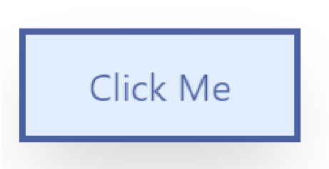After hover

**Add button “Click Here” and design it as shown in image. Add hover effect and button will be displayed as shown in below image. Also, add transition and add animation of your choice.**

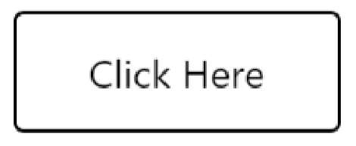After hover

<head>

<script src="https://cdn.tailwindcss.com"></script>

</head>

<body>

<a class="hover:animate-pulse my-11 mx-4 inline-block border-4 border-blue-900 textblue-900 px-10 py-4 hover:bg-blue-100 text-2xl hover:shadow-2xl " href="#" >Click Me</a>

<button class="hover:animate-bounce px-10 py-4 bg-black text-white my-11 mx-4 text2xl hover:text-black hover:bg-white hover:border-2 hover:border-black rounded-md transition-all duration-1000 hover:px-11 hover:py-5">Click Here</button>

</body>

**Example**

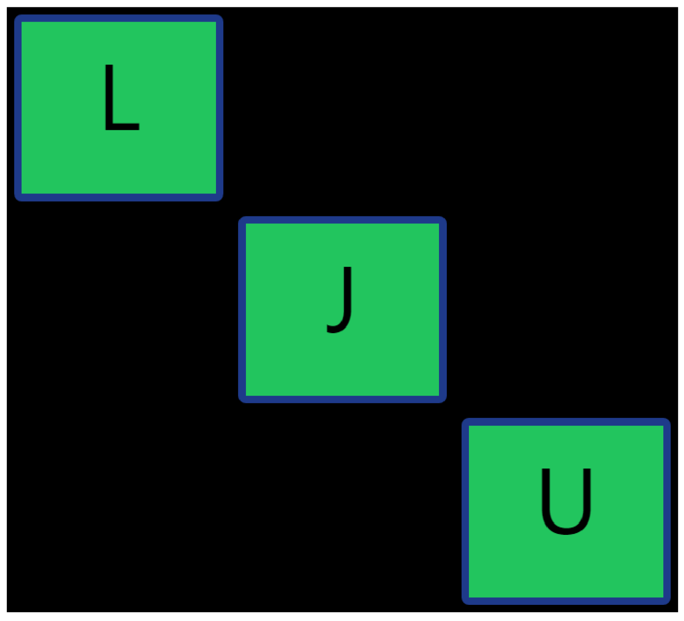

|  |
| --- |
| <div class="grid justify-items-auto grid-cols-3 bg-black m-4">  <div class="m-2 flex bg-green-500 rounded-lg border-8 border-blue-900 h-[200px] text[100px] justify-center">L</div>  <div></div>  <div ></div> <div ></div>  <div class="m-2 flex bg-green-500 border-8 border-blue-900 rounded-lg h-[200px] text[100px] justify-center">J</div>  <div></div>  <div ></div>  <div ></div>  <div class="m-2 flex bg-green-500 border-8 border-blue-900 rounded-lg h-[200px] text[100px] justify-center">U</div> </div> |

**Example**

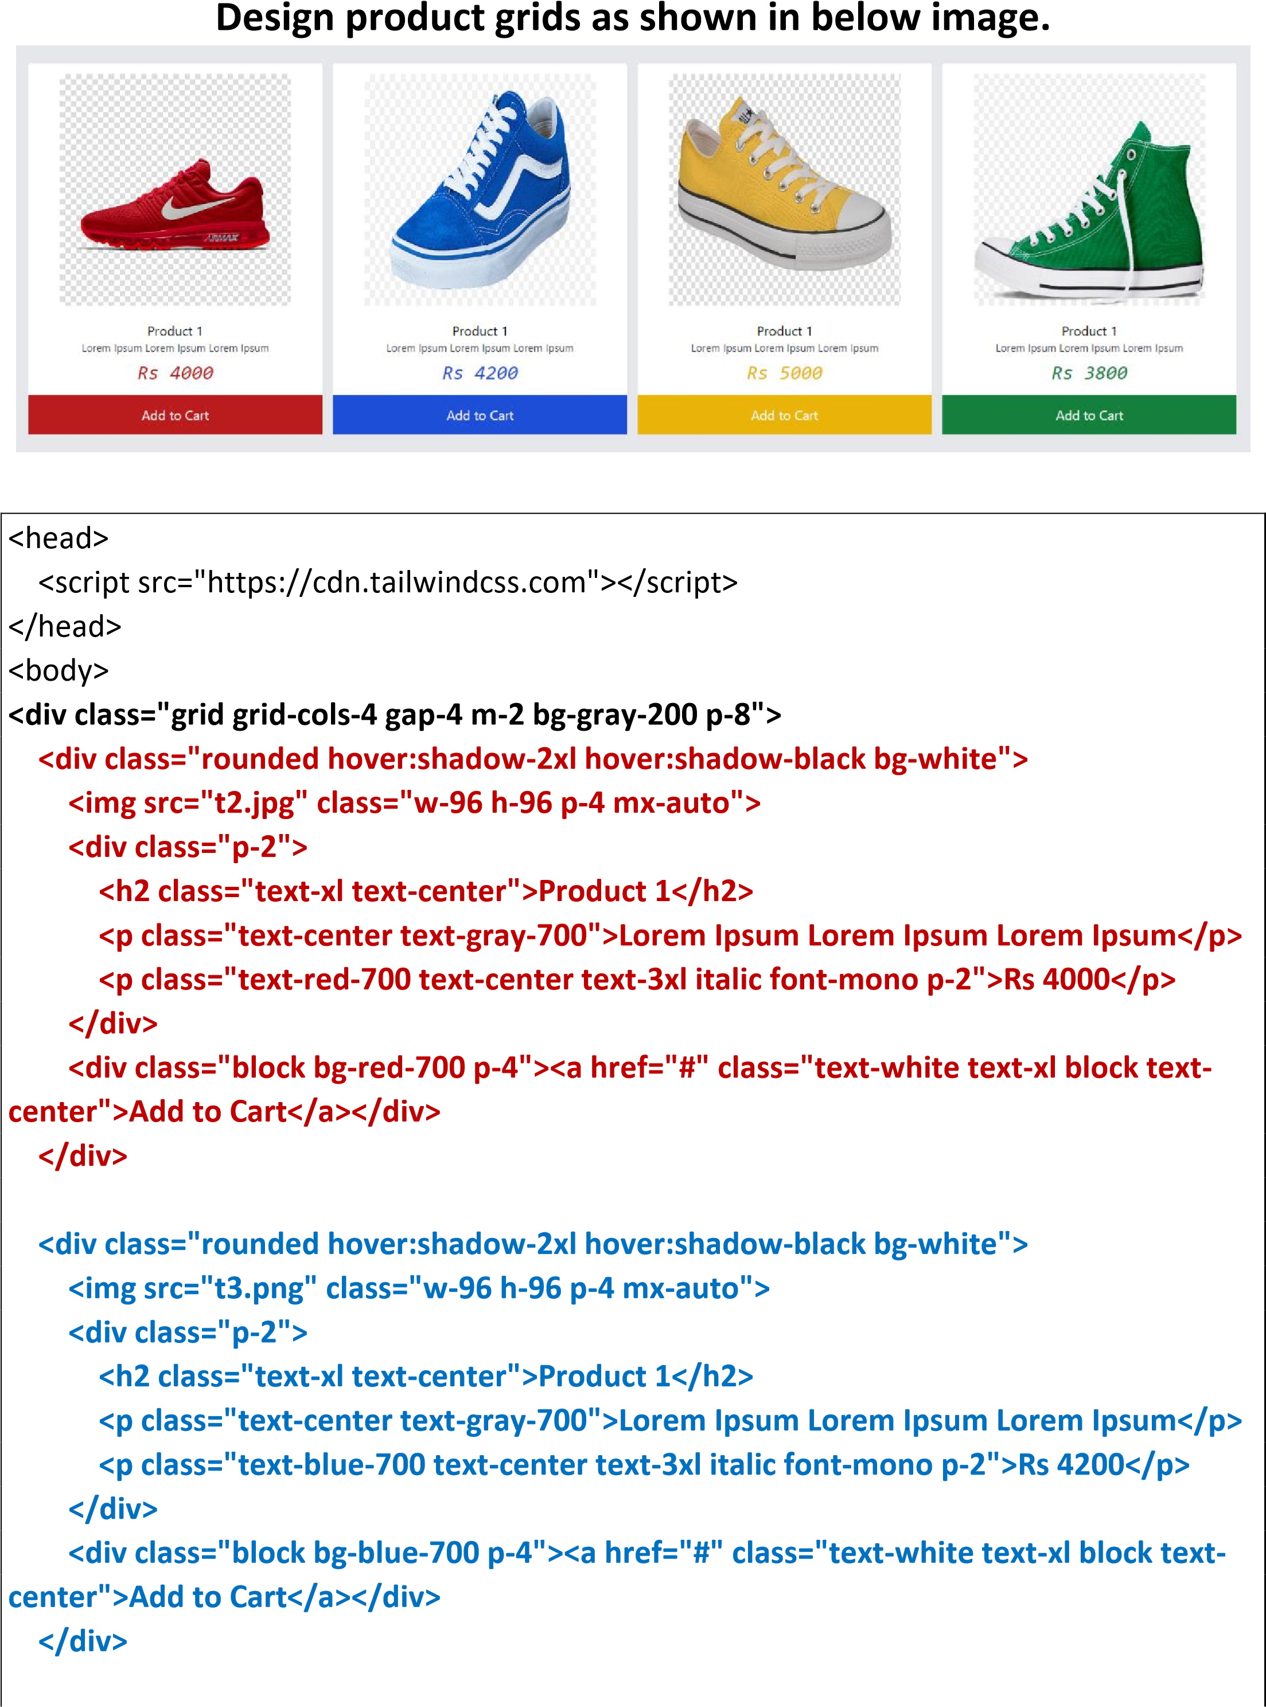

**<div class="rounded hover:shadow-2xl hover:shadow-black bg-white">**

**<img src="t1.jpg" class="w-96 h-96 p-4 mx-auto">**

**<div class="p-2">**

**<h2 class="text-xl text-center">Product 1</h2>**

**<p class="text-center text-gray-700">Lorem Ipsum Lorem Ipsum Lorem Ipsum</p>**

**<p class="text-yellow-500 text-center text-3xl italic font-mono p-2">Rs 5000</p>**

**</div>**

**<div class="block bg-yellow-500 p-4"><a href="#" class="text-white text-xl block textcenter">Add to Cart</a></div>**

**</div>**

**<div class="rounded hover:shadow-2xl hover:shadow-black bg-white">**

**<img src="t4.png" class="w-96 h-96 p-4 mx-auto">**

**<div class="p-2">**

**<h2 class="text-xl text-center">Product 1</h2>**

**<p class="text-center text-gray-700">Lorem Ipsum Lorem Ipsum Lorem Ipsum</p>**

**<p class="text-green-700 text-center text-3xl italic font-mono p-2">Rs 3800</p>**

**</div>**

**<div class="block bg-green-700 p-4"><a href="#" class="text-white text-xl block textcenter">Add to Cart</a></div>**

**</div>**

**</div>**

</body>

**Example**

Design navbar as shown in below image using tailwind classes. Also add

**animated utility to make an element gently fade in and out**

nav class="bg

<

-

black

p

-

4

m

-

>

"

8

<

div class="mx

-

auto flex justify

-

between">

<!

--

Logo on the left

--

>

div class="text

<

-

red

-

text

700

-

xl">

<

a href="#">Logo</a

>

<

/div

>

<!

--

Links in the middle

--

>

>

<

div

a href="#"

<

class="font

-

extrabold text

-

white p

-

hover:text

2

-

red

-

Home</a

>

800">



<a href="#" class="font-extrabold text-white p-2 hover:text-red-800">About</a>

<a href="#" class="font-extrabold text-white p-2 hover:text-red-800">Services</a> <a href="#" class="font-extrabold text-white p-2 hover:text-red-800">Contact</a>

</div>

<!-- Login link on the right -->

<div>

<a href="#" class="animate-pulse text-red-900 font-extrabold hover:text-red-900 border-2 p-2 bg-white rounded-xl border-red-900">Login</a>

</div>

</div>

</nav>